# S2010 MT 1 EEE174

1. Int 21h, Function 09h requires three things set up before calling in order to correctly print a string, Hello_msg. They are:

**DS = SEG Hello_msg, DX=OFFSET Hello_msg, Hello_msg terminated with 36**

2. Moore’s Law has accurately predicted the growth rate in the number of transistors per die for the last 40 years. What is the rate?

**Doubling every 18 – 24 months**

3. Given:

AX=0353 BX=0534 CX=0000 DX=0180 SP=FFEE BP=0000 SI=0000 DI=0000

DS=1D72 ES=1D72 SS=1D72 CS=1D72 IP=0109 OV UP EI PL NZ NA PO CY

1D72:0109 7D06 JNL 0118

What will the IP value be after a “t” command is executed in DOS Debug?

**010B**

4. A “NOP” instruction will:

**Perform a No OPeration**

5. Given:

AX=F247 BX=0000 CX=0000 DX=0000 SP=FFEE BP=0000 SI=0000 DI=0000

DS=1D72 ES=1D72 SS=1D72 CS=1D72 IP=0106 NV UP EI NG NZ NA PE NC

1D72:0106 EB0F JMP 0118

What will the IP value be after a “t” command is executed in DOS Debug?

**0118h**

6. In x86 architecture, BIU stands for which of the following?

**Bus Interface Unit**

7. Determine the contents of register BL after the following instructions have been executed:

**2EH**

8. The number of bytes in a double word are:

**4**

9. In x86 architecture, ALU stands for which of the following?

**Arithmetic Logic Unit**

10. The “LOOPNE” instruction is equivalent to which of the following instructions?

**DEC CX, JNE**

11. The instruction MOV CX, DADD is what addressing mode?

**Immediate**

12. Here is a short sequence of code: 7413EBA3CD167D213C04EBF0EB15. All of the instructions are a word long. The third instruction operator is:

**INT**

13. Which of the following DOS Debug instructions would set a break point at memory location 010C?

**G = 100 10C**

14. How many bytes are there in this short sequence of code? B400CD164CCD21

**7**

15. How many address lines would be required to address 128 MB directly?

**27**

16. What are the contents of CX after this program has been run:

**D800h**

17. 1010 0110 in 2’s complement equals____ in base 10.

**-90**

18. What is the hexadecimal encoding for adding AX with BX and storing the result in AX?

**01D8**

19. What is 11.437510 in binary?

**001011.01110**

20. If CX is 0000 what will CX be after a “LOOP” instruction?

**FFFF**

21. What is the hexadecimal encoding for “JGE” for a jump back 12 bytes?

**7DFA**

22. Given:

AX=FFE0 BX=3534 CX=0000 DX=0180 SP=FFEE BP=0000 SI=0000 DI=0000

DS=1D72 ES=1D72 SS=1D72 CS=1D72 IP=010E OV UP EI PL NZ NA PO NC

1D72:010F 7D08 JGE 0115

How many bytes will the processor jump if the conditions for a jump were met?

**8**

23. What command in DEBUG would be used to execute interrupts?

**P**

24. What is the advantage of C Language over Assembly Language?

**C is transportable to other microprocessor architectures**

25. In adding 5+5 through a 4 bit integer unit. The state of the OF and CF flags after the add instruction would be:

**OF = 1, CF = 0**

26. In MASM, with a “MOV CX, 24” instruction, and a “LOOP” instruction, in decimal how many times will the program loop?

**36**

27. Given:

AX=0353 BX=3534 CX=0000 DX=0180 SP=FFEE BP=0000 SI=0000 DI=0000

DS=1D72 ES=1D72 SS=1D72 CS=1D72 IP=010D NV UP EI PL NZ NA PO NC

1D72:010D 7DF6 JNL 0116

**-10**

28. AND’ing 1FH and 20H will result in which of the following?

**0**

29. Given:

13A7:0110 CD 20 32 20 54 48 39 73-20 69 73 20 74 68 65 20

13A7:0120 66 69 72 73 74 20 4D 69-64 74 65 72 6D 0D 24 D9

13A7:0130 00 C6 00 00 00 00 00 00-00 00 00 00 00 00 00 00

An input buffer is at memory location 0115, what is the size of the buffer in decimal?

**72**

30. A microprocessor with a 31-bit address bus could access how much memory?

**2 GB**

31. For the instruction sequence below, determine the contents of the register AL after this program is executed:

**51H**

32. Given:

AX=FF00 BX=3534 CX=0000 DX=0180 SP=FFEE BP=0000 SI=0000 DI=0000

DS=1D72 ES=1D72 SS=1D72 CS=1D72 IP=0109 OV UP EI PL NZ NA PO CY

1D72:0109 7D06 JNL 0118

What is the signed decimal value of the number in the AX register?

**-256**

33. The ASCII codes for space, space, carriage return, line feed, end of string in decimal are:

**32, 32, 13, 10, 36**

# S2010 MT2 EEE174

1. How many bit(s) is/are required to represent a range of decimal numbers from0 to 127?

**7**

2. If CX is 0003, what will CX be after a “LOOP” instruction?

**0002**

3. IN the Propeller microcontroller, the command “waitcnt(clkfreq*5 + cnt)” would cause the processor to do which of the following?

**A 5 second delay**

4. What is the number 1011.01012 in decimal?

**11.31**

5. This section of memory represents a stack. What type of program is this?

BEEF : FFD0 00 00 00 00 00 00 00 00-00 00 00 00 00 00 00 00

BEEF : FFE0 00 01 02 03 04 05 06 07-08 09 0A 0B 0C 0D 0E 0F

BEEF : FFF0 11 22 33 44 55 66 77 88-99 AA BB CC DD EE FF

**COM program**

6. With a POPA instruction, what will be the order of the accumulator, base, count, and data registers restored from the stack?

**BDCA**

7. Determine the contents of register BL after the following instruction have been executed:

**2EH**

8. What Hex values must be sent to address the key pad rows on the PPE board?

**1, 2, 4, 8**

9. What is the number 32.437510 in binary?

**100000.01110**

10. In MASM, with a “MOV CX, 18h” instruction, and a “LOOP” instruction, in decimal how many times will the program loop?

**24**

11. The acronym PWM used for motor control, is defined as which of the following?

**Pulse Width Modulation**

12. In the PIC18 with TRISD = 0b01111111, what is the configuration of the Port D?

**Bit 7 of port D is set to output**

13. Given the short code, what is the value in AX after the program is run?

**0500**

14. What flag(s) does the “LOOPNZ” instruction look at to determine whether to loop or not?

**ZF**

15. How many nibbles are in double precision IEEE floating point format number?

**16**

16. In the Hello MASM lab in the original code, what is the address of the byte used to start the number in the sequence “Hello World 0”?

**020E**

17. What type of program is this?

AX=0000 BX=0000 CX=0000 DX=0180 SP=FFEE BP=0000 SI=0000 DI=0000

DS=1476 ES=1576 SS=1376 CS=1D72 IP=0015 NV UP EI PL NZ NA PO NC

1376:0015 0100 ADD [BI + SI], AL DS : 0000=CD

**EXE**

18. If the SP is F00F, what is the SP value after a “PUSH CX” instruction?

**F00D**

19. In the PIC18 with TRISD = 0b00001111 and LATD = 0xAA, what value will be on Port D and shown on the LEDs?

**A0**

20. What is the numeric sequence of the key pad columns on the PPE board?

**37, 2F, 1F**

21. What is –130 decimal in 2’s complement (8bits)?

**01111110**

22. Which of the following is a valid x86 command for multiplying a number?

**MUL BX**

23. The number of bits in single precision IEEE floating point format are:

**32**

24. You are trying to rebuild a HELLO project program in MASM and you get the following error:

“LINK : warning L4021: no stack segment”.

What would be the reason for such an error?

**No project template for COM was selected**

25. A “pull down” resistor is used in digital circuits to do what?

**To keep the signal line “tied” low until the line is active (goes high)**

26. A “POP” instruction:

**increments the SP**

27. AND’ing 10H and 2FH will result in which of the following?

**0**

28. In the Propeller microcontroller, the command “dira[4..9] := %111111” would cause the processor to do which of the following?

**Sets the Propeller pins P4 through P9 as output pins**

29. What commands in MASM-CodeView would be used to step through a program line by line?

**T (F8)**

30. If the SP is F00F, what will the SP value be after a “POP SP” instruction?

**F011**

31. On the PPE board, what number(s) on the key pad is(are) pressed for an output port value of 08h and an input port value of 2Fh?

**0**

32. In the Propeller microcontroller, the term “Method” is(are) which of the following?

**A block of executable commands that has variables, can receive parameters, and returns a value.**

33. Using MASM, which of the following will cause a program with a LOOP instruction to loop 48 times in decimal?

**MOV CX, 30H or MOV CX, 48**

34. A “pull up” resistor is used in digital circuits to do what?

**To keep the signal “tied” high until the line is active (goes low)**

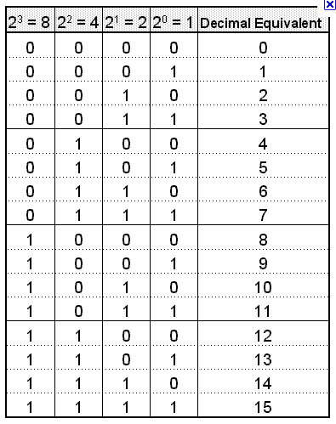

convert decimal 49 to binary:

49/2 = 24 r 1

24/2 = 12 r 0

12/2 = 6 r 0

6/2 = 3 r 0

3/2 = 1 r 1

1/2 = 0 r 1

Now read the remainders from bottom to top: The binary

equivalent is 110001

convert decimal 0.7 to binary:

0.7 * 2 = 1.4

0.4 * 2 = 0.8

0.8 * 2 = 1.6

0.6 * 2 = 1.2

0.2 * 2 = 0.4

0.4 * 2 = 0.8

0.8 * 2 = 1.6

0.6 * 2 = 1.2 etc. .10110011

Example: convert binary 1101001 to decimal:

1 + 8 + 32 + 64 = 105

Example: convert binary 0.1101001 to decimal :

.5 + .25 + .0625 + .0078125 = .8203125

**Spring 2012 EEE174**

1. What is the advantage of assembly language over C language?
   1. The assembler creates much faster executable code
2. How many lines would be required to address 128 mb directly?
   1. 27
3. In the x86 lab part 3 Hello MASM program in the original code, what is the address of the byte used to start the number in the sequence “Hello World 0”?
   1. 020E
4. Given

W e l c o m e _ t o _ A s s e m

0B0E:0200 57 65 6C 63 6F 6D 65 20-74 6F 20 41 73 73 65 6D

0B0E:0210 62 6C 79 20 4C 61 6E 67-75 61 67 65 00 00 00 00

b l y _ L a n g u a g e

An Ascii message begins at memory location 0200, what is the message?

* 1. Welcome to Assembly Language

1. Which of the following DOS Debug instructions would be used to change the IP register to 0110?
   1. RIP
2. Moore’s law has accurately predicted the growth rate in the number of transistors per ide for the last 40 years. What is the rate?
   1. Doubling every 18 – 24 months
3. Which of the following DOS debug instructions would set a break point at memory location 010C?
   1. G = 1000 10C
4. AND’ing 1FH and 02H will result in which of the following?
   1. 02MASM**register in MASM**
5. If CX is 0000 what will CX be after a “LOOP” instruction?
   1. FFFF
6. The number of bits in a word are:
   1. 16
7. In x86 architecture, ALU stands for which of the following?
   1. Arithmetic Logical Unit
8. Given:

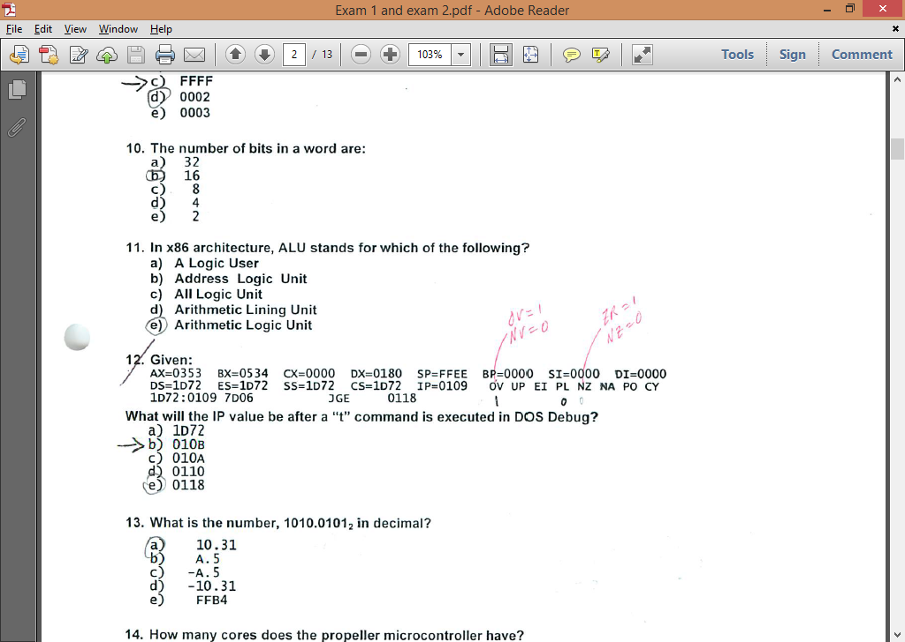

What will the IP value be after a “t” command is executed in DOS DEBUG?

* 1. 010B

1. What is the number 1010.01012 in decimal?
   1. 10.31
2. How many cores does the propeller microcontroller have?
   1. 8
3. What is the hexadecimal encoding for “JGE” for a jump back 12 bytes?
   1. 7DF2
4. What command in debug would be used to step through a program line by line?
   1. T
5. Here is a short sequence of code: 74 13 EB A3 CD 16 7D 21 3C 04 EB F0 EB 15. All of the instructions are a word long The third instruction operator is:
   1. INT
6. In MASM, with a “MOV CX, 24” instruction, and a “LOOP” instruction, in decimal how many times will the program loop?
   1. 24
7. Given:

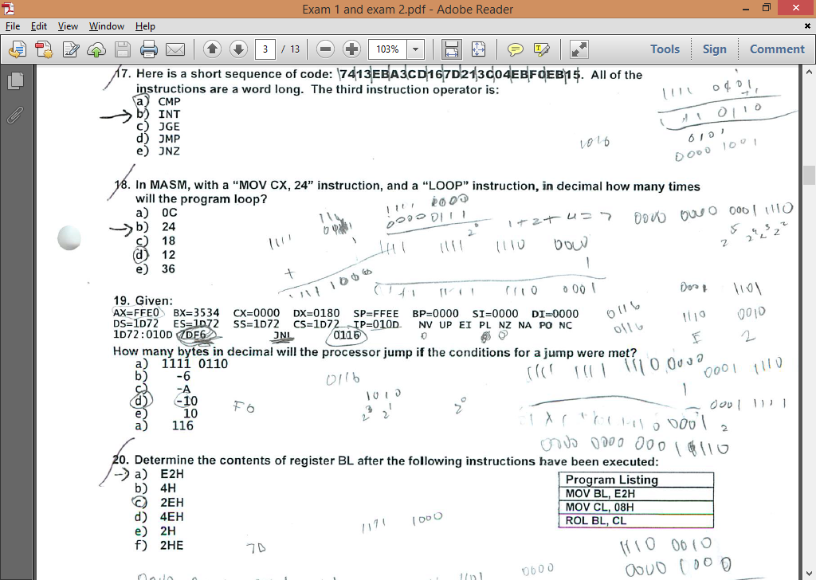

How many bytes in decimal will the processor jump if the conditions for a jump were met?

* 1. -10

1. Determine the contents of the register BL after the following instructions have been executed: 
   1. E2H
2. The ASCII codes for space, space, carriage return, line feed, end of string in hexadecimal are:
   1. 20, 20, 0D, 0A, 24
3. AND’ing 10H and 2FH will result in which of the following?
   1. 0
4. A “NOP” instruction in a program will
   1. Perform a No Operation
5. Given:

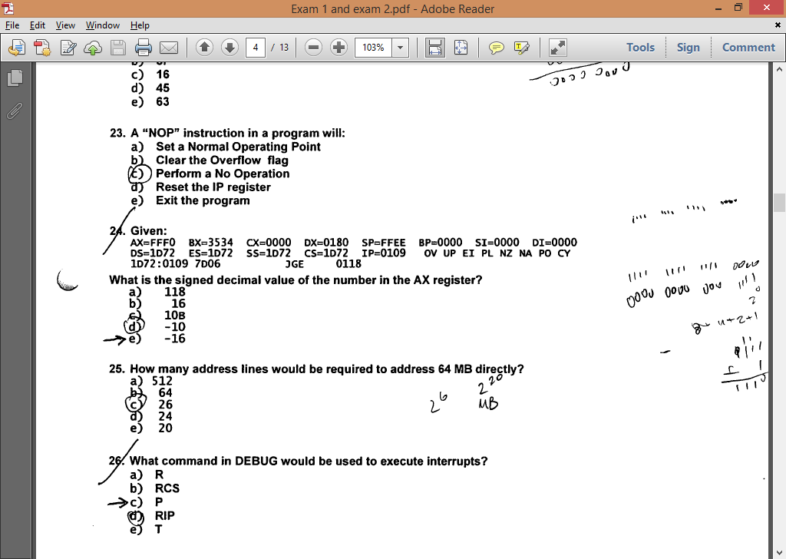

What is the signed decimal value of the number in the AX register?

* 1. -16

1. How many address lines would be required to address 64 MB directly?
   1. 26
2. What command in debug would be used to execute interrupts?
   1. P
3. What high level language is the propeller programmed in?
   1. Spin
4. Which of the following DOS debug instructions would be used to change the IP register to 010C?
   1. RIP
5. The acronym PWM used in Parallax Propeller and MicroChip PIC18, is defined as:
   1. Pulse width modulation
6. Which command would you use to execute another core in the propeller microcontroller?
   1. Cognew
7. Given:

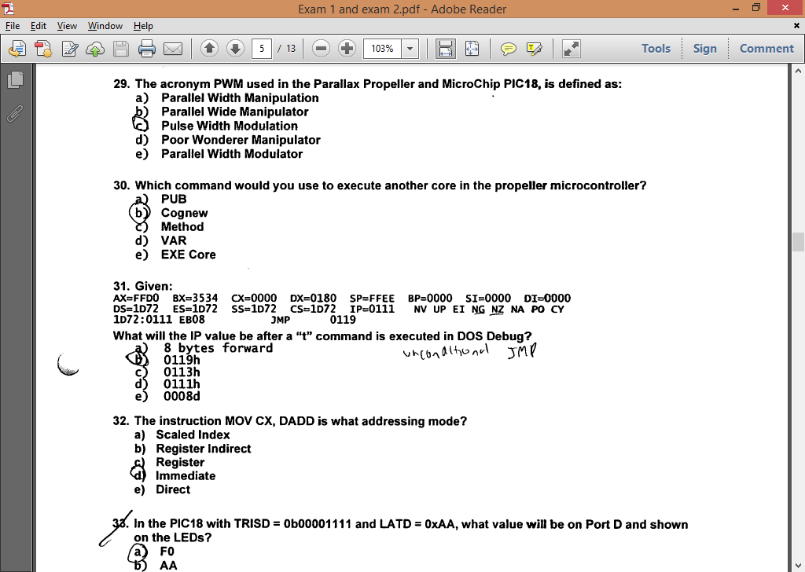

What will the IP value be after the “t” command is executed in DOS debug?

* 1. 0119h

1. The instruction MOV CD, DADD is what addressing mode?
   1. Immediate
2. In the PIC18 with TRISD = 0b00001111 and LATD = 0xAA, what value will be on Port D and shown on the LEDs?
   1. F0
3. How many byte in decimal will the processor jump if the conditions for a jump are met?
   1. 24
4. In the Propeller microcontroller, the command “dira[4..9] := %111111” would cause the processor to do which of the following?
   1. Sets the Propeller pins P4 through P9 as output pins
5. What are the contents of DX after this program has been run: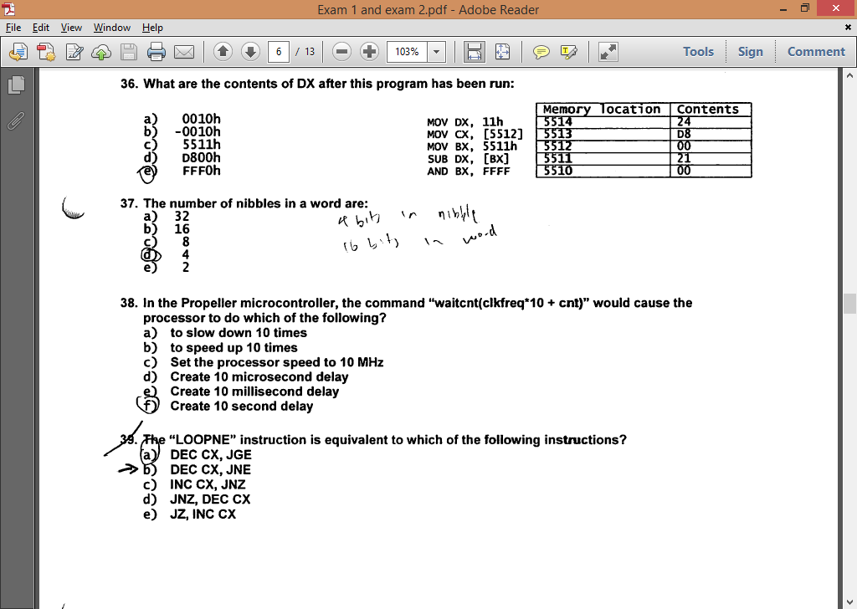
   1. FFF0h.
6. The number of nibbles in a word are:
   1. 4
7. In the Propeller microcontroller, the command “waitcnt(clkfreq*10 + cnt)” would cause the processor to do which of the following?
   1. Create 10 second delay
8. The “LOOPNE” instruction is equivalent to which of the following instructions?
   1. DEC CX JNE
9. Given

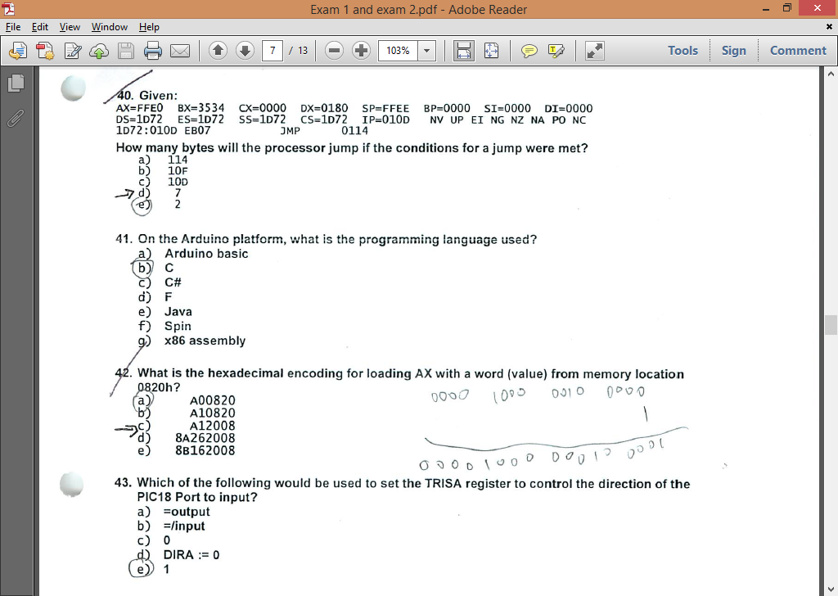

How many bytes will the processor jump if the conditions for a jump were met?

* 1. 7

1. On the Arduino platform, what is the programming language used?
   1. C
2. What is the hexadecimal encoding for loading AX with a word (value) from memory location 0820h?
   1. A12008
3. Which of the following would be used to set the TRISA register to control the direction of PIC18 Port to input?
   1. 1
4. The acronym ADC in microcontrollers stands for which of the following?
   1. Analog to Digital converter
5. In adding 5+5 through a 4 bit integer unit. The state of the 0F and CF flags after the add instruction would be:
   1. 0F = 1, CF = 0
6. Given:

0B0E:0200 57 65 6C 63 6F 6D 65 20-74 6F 20 74 68 65 20 66

0B0E:0210 69 72 73 74 20 64 61 79-20 6F 66 20 74 68 65 20

0B0E:0220 72 65 73 74 20 6F 66 20-79 6F 75 72 20 6C 69 66

0B0E:0230 65 00 00 00 00 00 00 00 00 00 00 00 00 00 00 00

An ASCII message begins at memory location 0200, what is the message?

* + **Welcome to the first day of the rest of your life**

1. The instruction MOV DX, BADD is what addressing mode?
   * **Immediate**
2. Which of the following is the hexadecimal encoding for adding BX with CX and storing the result in CX?
   * **03CB**
3. What is the advantage of Assembly Language over C Language?
   * **The Assembler creates much faster executable code**
4. What is 18.437510 in binary?
   * **010010.01110**
5. For the instruction sequence below, determine the contents of the register AL after this program is executed:
   * **51H**
6. In x86 architecture, ALU stands for which of the following?
   * **Arithmetic Logic Unit**
7. A microprocessor with a 33-bit address bus could access how much memory?
   * **8 GB**
8. What is the hexadecimal encoding for “JGE” for a jump back 12 bytes?
   * **7DF2**
9. Given:

AX=FFE0 BX=3534 CX=0000 DX=0180 SP=FFEE BP=0000 SI=0000 DI=0000

DS=1D72 ES=1D72 SS=1D72 CS=1D72 IP=010F NV UP EI NG NZ NA PO NC

1D72:010F 7D18 JGE 0128

How many bytes in decimal will the processor jump if the conditions for a jump are met?

* 1. **24**

1. Moore’s law has accurately predicted the growth rate in the number of transistors per die for the last 40 years. What is that rate?
   1. **Doubling every 18-24 months**
2. The number of bytes in a word are:
   1. **2**
3. Determine the contents of register BL after the following instructions have been executed:
   1. **2EH**
4. How many bit(s) is/are required to represent a range of decimal numbers from 0 to 127?
   1. **7**
5. What high level language is the propeller programmed in?
   1. **Spin**
6. In the Propeller microcontroller, the command “dira[4..9] := %000000” would cause the processor to do which of the following?
   1. **Sets the Propeller pins P4 through P9 as input pins**
7. Which command would you use to execute another core in the propeller microcontroller?
   1. **Cognew**
8. How many cores does the propeller microcontroller have?
   1. **8**
9. In the Propeller microcontroller, the command “waitcnt(clkfreq*10 + cnt)” would cause the processor to do which of the following?
   1. **Create 10 second delay**
10. The acronym ADC in microcontrollers stands for which of the following?
    1. **Analog to Digital Converter**
11. The acronym PWM used in the Parallax Propeller and Microchip PIC18, is defined as:
    1. **Pulse Width Modulation**
12. How many bits does the PIC18 microcontroller use in the PICkit 3 Debug Express have?
    1. **8**
13. Which of the following would be used to set the TRISA register to control the direction of the PIC18 Port to input?
    1. **1**
14. In the PIC18 with TRISD = 0b01111111, what is the configuration of the Port D?
    1. **Bit 7 of port D is set to output**
15. In the PIC 18 with TRISD = 0b11110000 and LATD = 0xAA, what value will be on Port D and shown on the LEDs?
    1. **0A**
16. On the Arduino platform, what is the programming language used?
    1. **C**
17. Given:

AX=FFD0 BX=3534 CX=0000 DX=0180 SP=FFEE BP=0000 SI=0000 DI=0000

DS=1D72 ES=1D72 SS=1D72 CS=1D72 IP=0111 NV UP EI NG NZ NA PO CY

1D72:0111 EB08 JMP 0119

What will the IP value be after a “t” command is executed in DOS Debug?

* 1. **0119h**

1. How many bytes are there in this short sequence of code? B4 00 CD 16 4C CD 21 CD 20
   1. **9**
2. In x86 architecture, BIU stands for which of the following?
   1. **Bus Interface Unit**
3. Here is a short sequence of code: 74 13 EB A3 CD 16 7D 21 3C 04 EB F0 EB 15. All of the instructions are a word long. The fifth instruction operator is:
   1. **CMP**
4. The ASCII codes for space, space, carriage return, line feed, end of string in decimal are:
   1. **32, 32, 13, 10, 36**
5. A “NOP” instruction in a program will:
   1. **Perform a No Operation**
6. Given:

AX=FFF0 BX=3534 CX=0000 DX=0180 SP=FFEE BP=0000 SI=0000 DI=0000

DS=1D72 ES=1D72 SS=1D72 CS=1D72 IP=0109 OV UP EI PL NZ NA PO CY

1D72:0109 7D06 JNL 0118

What is the signed decimal value of the number in the AX register?

* 1. **-16**

1. Which of the following DOS Debug instructions would set a break point at memory location 010C?
   1. **G = 100 10C**
2. In adding 5+7 through a 4 bit integer unit, the state of the OF and CF flags after the add instruction would be:
   1. **OF = 1, CF = 0**
3. Given:

AX=FFD0 BX=3534 CX=0000 DX=0180 SP=FFEE BP=0000 SI=0000 DI=0000

DS=1D72 ES=1D72 SS=1D72 CS=1D72 IP=010D OV UP EI NG ZR NA PO NC

1D72:010D 7509 JNZ 0116

What will the IP value be after a “t” command is executed in DOS Debug?

* 1. **010Fh**

1. What are the contents of DX after this program has been run:
   1. **FFF0h**
2. Which of the following DOS Debug instructions would be used to change the IP register to 010C?
   1. **RIP**
3. What is the number, 1010.01012 in decimal?
   1. **10.31**
4. What command in DEBUG would be used to step through a program line by line?
   1. **T**
5. AND’ing 1FH and 02H will result in which of the following?
   1. **02**
6. How many address lines would be required to address 64 MB directly?
   1. **26**

**174 Cheat Sheet**

1010 0110 in 2’s complement equals in base 10 ➔ **-90**

A microprocessor with a 32-bit address bus could access how much memory➔ **4GB**

A6 in 2’s complement equals in base 10 ➔ **-90**

A “POP” instruction: ➔ **Increments the SP**

A “PUSH” instruction ➔ **decrements the SP**

A “NOP” instruction in a program will ➔ **Perform a No Operation**

AND’ing 1FH and 02H will result in which of the following ➔ **02**

AND’ing 10H and 2FH will result in which of the following ➔ **0**

A “**pull down**” resistor is used in digital circuits to do what? ➔ **To keep the signal line “tied” low until the line is active (goes high)**

A “**pull up**” resistor is used in digital circuits to do what ➔ **To keep singal “tied” high until the line is active (goes low)**

Determine the contents of register BL after the following instructions have been executed:➔ **E2H**

MOV BL, E2H

MOV CL, 1000b

ROL BL, CL **; rotate BL by 8 to left = same value**

For the instruction sequence below, determine the contents of the registers AL after this program ➔ **51H**

MOV AL, 73h ; 0111 0011

ADD AL, 78h ; 0111 1000

DAA

if low nibble of AL > 9 or AF = 1 then:

AL = **AL + 6**

AF = 1

if AL > 9Fh or CF = 1 then:

AL = **AL + 60h**

CF = 1

For the instruction sequence below, determine the contents of the register AL after this program is executed ➔ **51H**  
 MOV AL, 83h ADD, AL, 68h

DAA

Given the short code, what is the value in AX after the program is run ➔ **0100** Mov BX, 0100 PUSH BX MOV AX, 0500 POP AX

Given the short code, what is the value in AX after the program is run ➔**0001** MOV BX, 0001

PUSH BX

MOV AX, 0500

POP AX

GIVEN: IP = 0106 Flags: NV UP EI NG NZ NA PE NC Instruction: JMP 011F

What will the IP value be after “t” command is executed in DOS Debug? ➔ **011FH** (Unconditional Jump)

GIVEN: IP = 0109 Flags: OV UP EI PL NZ NA PO CY Instruction: JGE 0118

What will the IP value be after a “t” command is executed in DOS Debug ➔ **010B**

(0109 + 0010 add two bytes)

GIVEN: IP=FFE0 Flags: OV UP EI PL NZ NA PO NC Instruction: JGE 0116: ID72:010D 7D**09**

How many bytes will the processor jump if the condition for a jump were met? ➔ **9**

GIVEN: AX= FFF0 IP = 0109 FALGS: OV UP EI PL NZ NA PO CY ID72: 010F **7D18** Instruction: JGE 0118. What is the signed decimal value of the number in the AX register? ➔ **-16**

Covert the number 7D18 into decimal.

GIVEN: IP= 010F Flags: NV UP EI NG NZ NA PO NC Instruction: JNL 0115.

How many bytes in decimal will the processor jump if the conditions for a jump were met ➔ **24**

GIVEN: 57 65 6C 63 6F 6D 65 20-74 6F 20 41 73 73 65 6D

62 6C 79 20 4C 61 6E 67-75 61 67 65 00 00 00 00

An ASCII message begins at memory location 0200, what is the message? ➔ **Welcome to Assembly Language**

Here is a short sequence of code: 7413 EBA3 CD16 7D21 3C04 EBF0 EB15. All of the instructions are a word long. The third instruction operator is ➔ **INT**

Here is a short sequence of code: 7413 A3EB CD16 7D21 3C04 EBF0 EB15. All of the instructions are a word long. The fourth instruction operator is ➔**JGE**

Here is a short sequence of code: B400 CD16 3C4A 7404 BC6A 7513. All of the instructions are two bytes long. The sixth instruction operator is ➔**JNZ**

How many cores does the propeller microcontroller have ➔ **8**

How many bits(s) is/are required to represent a range of decimal numbers from **0** to **15** ➔ **4**

How many bits(s) is/are required to represent a range of decimal numbers from **0** to **63** ➔ **6**

How many bits(s) is/are required to represent a range of decimal numbers from **0** to **127** ➔**7**

How many bits(s) is/are required to represent a range of decimal numbers from **0** to **255** ➔**8**

How many bytes are there in this short sequence of code B4 00 CD 16 4C CD 20 ➔ **7**

How many nibbles are there in this short sequence of code B4 00 CD 16 3C 4A 74 04 3C 6A 75 13 ➔**24**

How many bytes are in double precision IEEE floating point format numbers → **8**

How many nibbles are in double precision IEEE floating point format numbers → **16**

How many address lines would be required to address 128 MB directly ➔ **27** (128 x 1048576 = 134217728 and 2^27 = 134217728)

How many address lines would be required to address 64 MB directly ➔ **26** (64 x 1048576 = 67108864 and 2^26 = 67108864)

If CX is 0000, what will CX be after a “LOOP” instruction ➔ **FFFF**

If CX is 0003, what will CX be after a “LOOPNZ” instruction ➔**0002**

If the SP is **F00F**, what is the SP value after a “**PUSH CX**” instruction ➔ **F00D**

If the SP is **F00F**, what is the SP value after a “**POP CX**” instruction ➔ **F011**

If the SP is **F00F**, what is the SP value after a “**POP SP**” instruction ➔ **F011**

In adding 5+5 through a 4 bit integer unit. The state of the OF and CF flags after the add instruction would be ➔ **OF = 1, CF = 0**

In x86 architecture, BIU stands for which of the following ➔ **Bus Interface Unit**

In x86 architecture, ALU stands for which of the following → **Arithmetic Logic Unit**

In the x86 lab part 3 Hello MASM program in the original code, what is the address of the byte used to start the number in the sequence “Hello World 0”? ➔ **020E**

In MASM, with a “MOV CX, **24h**” instruction, and a “LOOP” instruction, how many times will the program loop in decimal ➔ **36**

In MASM, with a “MOV CX, **24**” instruction, and a “LOOP” instruction, how many times will the program loop in decimal ➔ **24**

In MASM, with a “MOV CX, 12h” instruction, and a “LOOP” instruction, how many times will the program loop in decimal ➔ **18**

In the Hello MASM lab in the original code, what is the address of the string to start the message “Hello World 0” ➔ **0200**

In the PIC18 with TRISD = 0b10000000, what is the configuration of the Port D ➔ **Bit 7 of port D is set to input**

In the PIC18 with TRISD = 0b01111111 and LATD = 0xAA, what value will be on Port D and shown on the LEDS ➔ **Bit 7 of port D is set to output** (because the first bit is zero = output)

In the PIC18 with TRISD = 0b00001111, what is the configuration of the Port D ➔ **A0 (First 4 are outputs and last four are inputs)**

In the PIC18 with TRISD = 0b11110000 and LATD = 0xAA, what value will be on Port D and shown on the LEDS ➔ **0A**

In the Propeller microcontroller, the command “dira[9..4] := %000000” would cause the processor to do which of the following ➔ **Sets the propeller pin P4 through P9 as output pins**

In the Propeller microcontroller, the command “dira[9..4] := %111111” would cause the processor to do which of the following ➔ **Sets the propeller pin P4 through P9 as output pins**

In the propeller microcontroller, the command “waitcnt(clkfreq*3 + cnt)” would cause the processor to do which of the following ➔ **A 3 second delay**

In the propeller microcontroller, the command “waitcnt(clkfreq*2 + cnt)” would cause the processor to do which of the following ➔ **A 2 second delay**

In the Propeller microcontroller, the term “Method” is (are) which of the following ➔ **A block of executable commands that has variables, can receive parameters, and returns a value.**

Int 10h uses what function code to write a character to the screen and advance the cursor by one character position ➔ **0Eh**

Int 21h, Function 09h requires three things set up before calling in order to correctly print a string:

**DS=SEG Hello_msg, DX=OFFSET Hello_msg, Hello_msg terminated with 24h**.

Ladder Logic is used in? ➔ **PLCs**

**Moore’s law** has accurately predicted the growth rate in the number of transistors per die for the last 40 years. What is the rate? ➔ **Doubling every 18-24 months**

On the Ardino platform what is the program language used ➔ **C**

On the **PPE board**, what numbers(s) on the key pad is(are) pressed for an output port value of 08h and an input port value of 2Fh ➔ **0**

On the **PPE board**, what numbers(s) on the key pad is(are) pressed for an output port value of 04h and an input port value of 2Fh ➔ **8**

The “LOOPNZ” instruction is equivalent to which of the following instructions ➔ **DEC CX, JNE**

The acronym PWM used for motor control, is defined as which of the following ➔ **Pulse Width Modulation**

The acronym PLC, is defined as which of the following? ➔ **Programmable Logic Controller**

The ASCII codes for space, space, carriage return, line feed, end of string in **decimal** are ➔ **32, 32, 13,10, 36**

The ASCII codes for space, space, carriage return, line feed, end of string in **hexadecimal** are:→ **20,20,0D,0A,24**

The binary number, 1011 0101, represents what values as a unsigned binary, 8 bit signed binary, odd parity ASCII, and BCD number (in that order) **➔ 181, -76, 5, invlaid5**

The instruction MOV CX, DADD is what addressing mode ➔ **Immediate**

The instruction MOV CX, [DADD] is what addressing mode ➔ **Direct**

The number of bits in single precision IEEE floating pint format are → **32**

This section of memory represents a stack. What type of program is this ➔ **EXE PROGRAM** **BEEF:00D0** 00 00 00 00 00 00 00 00-00 00 00 00 00 00 00 00 **BEEF:00E0** 00 01 02 03 04 05 06 07-08 09 0A 0B 0C 0D 0E 0F **BEEF:00F0** 11 22 33 44 55 66 77 88-99 AA BB CC DD EE FF

**BEEF:0FD0** 00 00 00 00 00 00 00 00-00 00 00 00 00 00 00 00 **BEEF:0FE0** 00 01 02 03 04 05 06 07-08 09 0A 0B 0C 0D 0E 0F **BEEF:0FF0** 11 22 33 44 55 66 77 88-99 AA BB CC DD EE FF

This section of memory represents a stack. What type of program is this ➔ **COM PROGRAM** **BEEF:FFD0** 00 00 00 00 00 00 00 00-00 00 00 00 00 00 00 00 **BEEF:FFE0** 00 01 02 03 04 05 06 07-08 09 0A 0B 0C 0D 0E 0F **BEEF:FFF0** 11 22 33 44 55 66 77 88-99 AA BB CC DD EE FF

Using MASM, which of the following will cause a program with a LOOP instruction to loop 48 times in decimal ➔ **MOV CX, 48**

Which command would you use to execute another core in the propeller microcontroller➔ **Cognew**

What command in DEBUG would be used to change the code segment ➔ **RCS**

What command in DEBUG would be used to change the IP value ➔ **RIP**

What command in DEBUG would be used to execute interrupts ➔ **P**

What command in MASM-CodeView would be used to step through a program line by line ➔ **T(F8)**

What flag(s) does the “LOOPNZ” instruction look at to determine whether to loop or not ➔ **ZF**

What flag(s) does the “LOOPNE” instruction look at to determine whether to loop or not ➔ **ZF**

What Hex values must be sent to address the key pad rows on the PPE board ➔ **1,2,4,8**

What is the advantage of C Language over Assembly Language ➔ **C is transportable to other microprocessor architectures**

What is the hexadecimal encoding for “JGE” for a jump back 10 bytes ➔ **7DF4 (10 byes + 2 )**

What is the hexadecimal encoding for adding AX with BX and storing the result in AX ➔ **01D8**

ADD AX, BX 000 00W 11 reg1 reg2

What is the hexadecimal encoding for adding BX with CX and storing the result in BX ➔ **01CB**

What is the hexadecimal encoding for adding BX with DX and storing the result in BX ➔ **01D3**

What is -130 decimal in 2’s complement (8bits) ➔ **01111110**

What is -32.75 in a base two number system ➔ **-100000.110000**

What is 14.4375 in binary ➔ **001110.0110**

What is 16.4375 in binary ➔ **010000.01110**

What is the binary value of decimal 12.875 ➔ **1100.1110**

What is 16.4375 in binary → **010000.01110**

What is number, 1011.0101 (2) in decimal? ➔ **11.31**

What is the **numeric sequence** of the key pad columns on the PPE board ➔ **37,2F,1F**

What is the decimal value of C5 5A 57 00 in IEEE single precision FP format → **-3493.4375**

What of the following instruction would be used to set the LED to light on the Arudino platform ➔ **digitalWrite(ledPin, HIGH);**

What type of program is this ➔ **EXE** IP = **0115**, 1376:0115 0100 ADD [BX+SI], AL DS:0000=CD

What type of program is this ➔ **COM** IP = 0100, 1376:0100 0100 ADD [BX+SI], AL DS:0000=CD

Which of the following DOS Debug instructions would set a break point at memory location 010C ➔ **G = 100 10C**

Which of the following would be used to set the **TRISA** register to control the direction of **PIC18** port to **input** ➔ **1** and for **output** its ➔ **0**

Which of the following DOS Debug instructions would be used to change the IP register to 110 ➔**RAX = 0110**

Which of the following will cause a program with a LOOP instruction to loop 48 times (decimal)➔ **CX=30h**

Which of the following is a valid x86 command for multiplying a number ➔ **MUL BX**

Which of the following is **not a valid** command for a number into a register in MASM ➔ **MOV AX, BADH**

With a POP BX instruction, what will be order off the accumulator, base, count, and data registers restored from the stack ➔ **BX**

With a POPA instruction, what will be the order of the accumulator, base, count, and data registers restored from the stack ➔ **BDCA**

You are trying to rebuild a HELLO program project in MASM and you get the following error: "ERROR 4 line 1". What is the cause of the error? ➔ **Not known—this error by itself isn’t a problem, press the enter key to clear the error.**

You are typing to rebuild a HELLO project program in MASM and you get the following error: “LINK : warring L4021: no stack segment”. What would be the reason for the such an error ➔ **No project template for COM was selected.**

You are typing to rebuild a HELLO project program in MASM and you get the following error: “LINK : fatal error L1089: HELLO.lrf: cannot open response file”. What would be the reason for the such an error ➔ **No source file is identified(no .asm file)**

**PPE** **Row Column** [**Scan**](https://moodle.ecs.csus.edu/file.php/107/LectureNotes/Lecture12/174lecture12_files/ppe-rowcolumnscandecoding2_7.pdf) **decoding**  
    D7 D6 D5 D4 D3 D2 D1 D0  
    S7 S6 S5 S4 S3 S2   
    ^ ^ ^   
    3 2 1  
    0 0 0 0 1 0 0 0 = 08h  
    0 0 0 1 0 0 0 0 = 10h  
    0 0 1 0 0 0 0 0 = 20h  
      
    0 0 1 1 1 1 1 1 = 3Fh -> Nothing pressed  
    0 0 1 1 0 1 1 1 = 37h -> Number 1 pressed  
    0 0 1 0 1 1 1 1 = 2Fh -> Number 2 pressed  
    0 0 0 1 1 1 1 1 = 1Fh -> Number 3 pressed

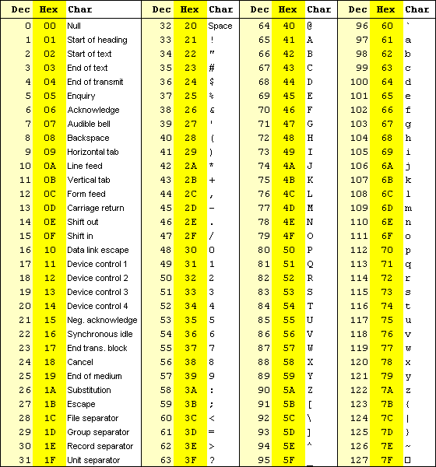

**INT Function**

5 Print Screen operation.

10h Video display services.

11h Equipment determination.

12h Memory size determination.

13h Diskette and hard disk services.

14h Serial I/O services.

15h Miscellaneous services.

16h Keyboard services.

17h Printer services.

18h BASIC.

19h Reboot.

1Ah Real time clock services

**CPE 64 Final Exam**

1. hichA “pull up” resistor is used in digital circuits to do what?
   1. To keep the signal “tied” high until the line is active (goes low)
2. How many Flip Flops would be required for a 5 state, State Machine?
   1. 3
3. 32 decimal would be what value in hexadecimal?
   1. 20
4. Which gate would be used for the function, F = /C/D + CD?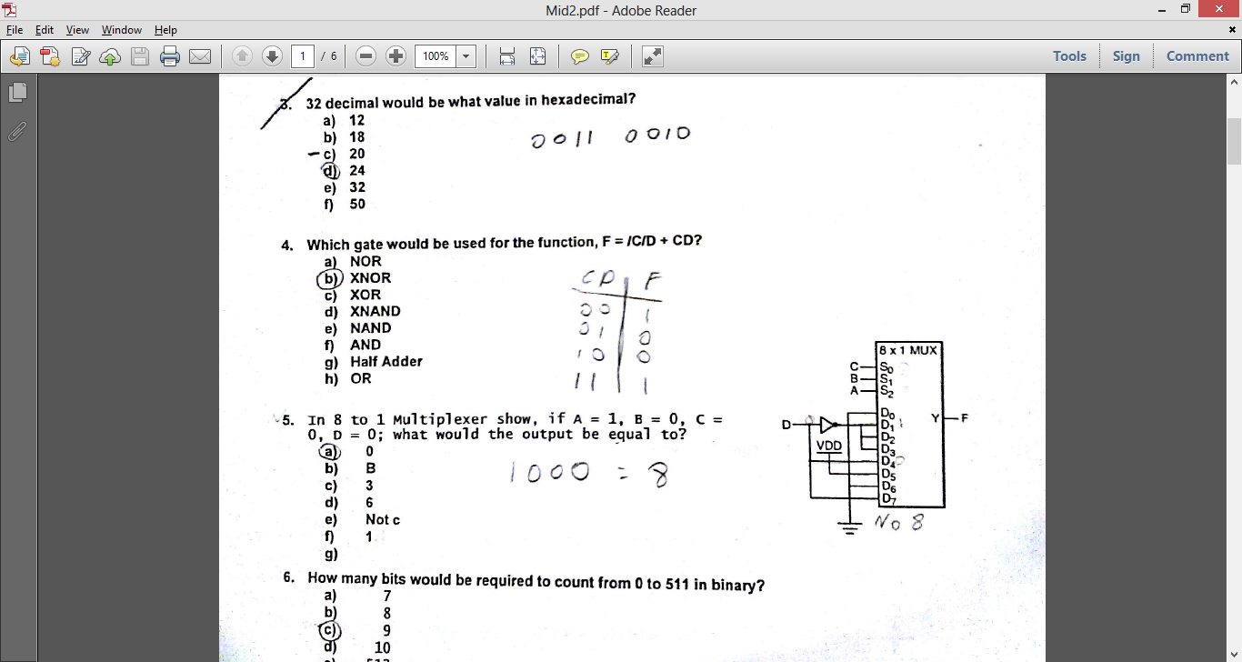
   1. XNOR
5. In 8 to 1 Multiplexer, show, if A = 1, B = 0, C = 0, D = 0; what would the output be equal too?
   1. 0
6. How many bits would be required to count from 0 to 511 in binary?
   1. 9
7. The Ladder Logic diagram would represent which of the following?
   1. NAND  
        
        
        
      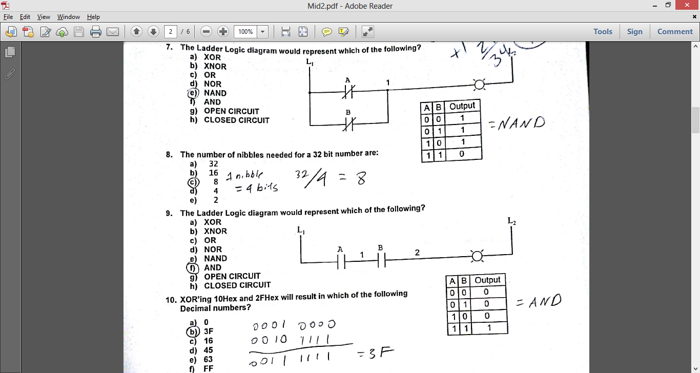
8. The number of nibbles needed for a 32 bit number are?
   1. 8

The number of nibbles needed for a 16 bit number are?

a=4

The number of nibbles in a Byte are:

A =2 

1. The Ladder Logic diagram would represent which of the following?
   1. AND  
        
        
      
2. XOR’ing 10Hex and 2FHex will result in which of the following numbers?
   1. 3F
3. The Ladder Logic diagram would represent which of the following?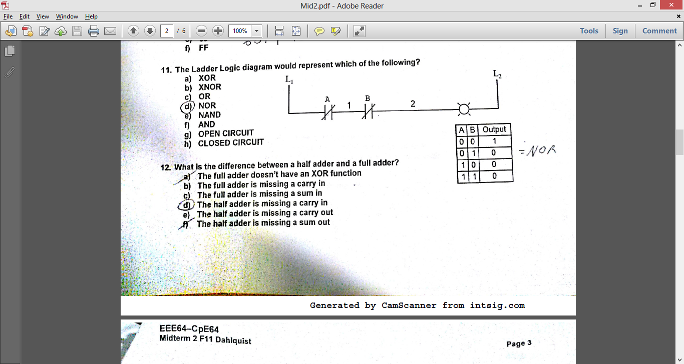
   1. NOR  
        
        
        
      
4. What is the difference between a half adder and a full adder?
   1. The half adder is missing a carry in
5. In the truth table shown; how many Karnaugh maps would be required to solve the truth table?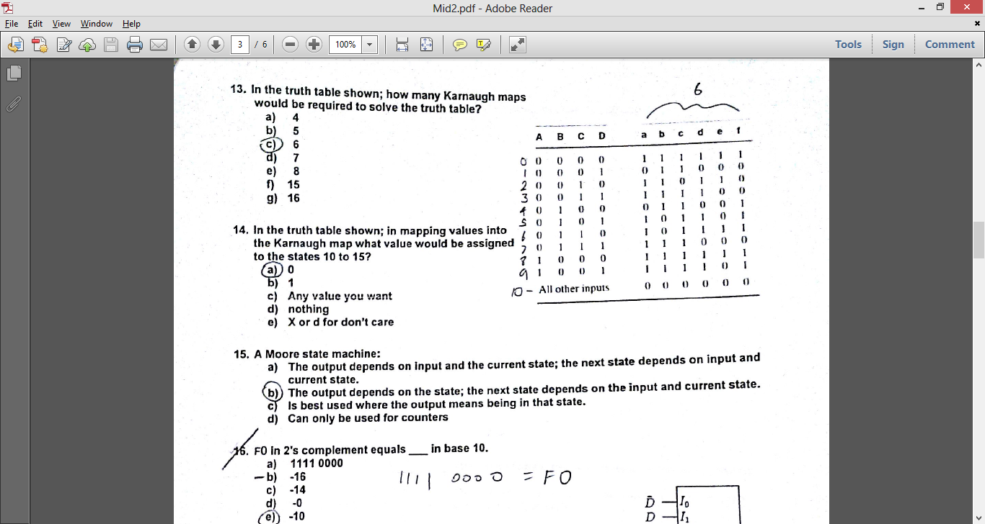
   1. 6
6. In the truth table shown; in mapping values to Karnaugh map what value would be assigned to the states 10 to 15?
   1. 0
7. A Moore state machine:
   1. The output depends on the state; the next state depends on the input and current state.
8. F0 In 2’s complement equals ___ in base 10.
   1. -16
9. In 8 to 1 Multiplexer shown, with A = 0, B = 1, C = 0; what would the value of output Y be equal to?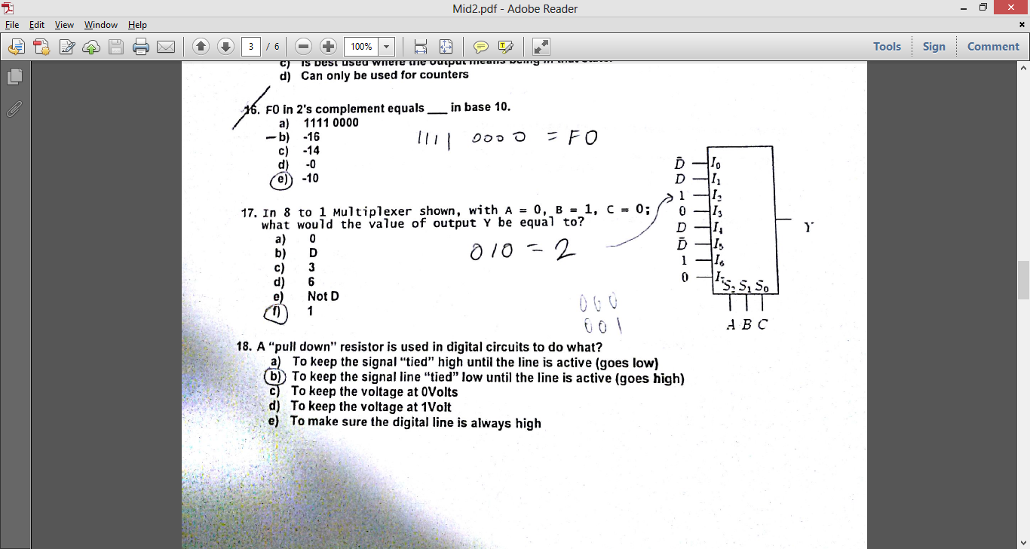
   1. 1
10. A “pull down” resistor is used in digital circuits to do what?
    1. To keep the signal line “tied” low until the line is active (goes high)
11. ADD’ing 10HEX and 2FHEX will result In which of the following Hex numbers?
    1. 3F
12. In the truth table shown; how many Karnaugh maps would be required to solve the truth table?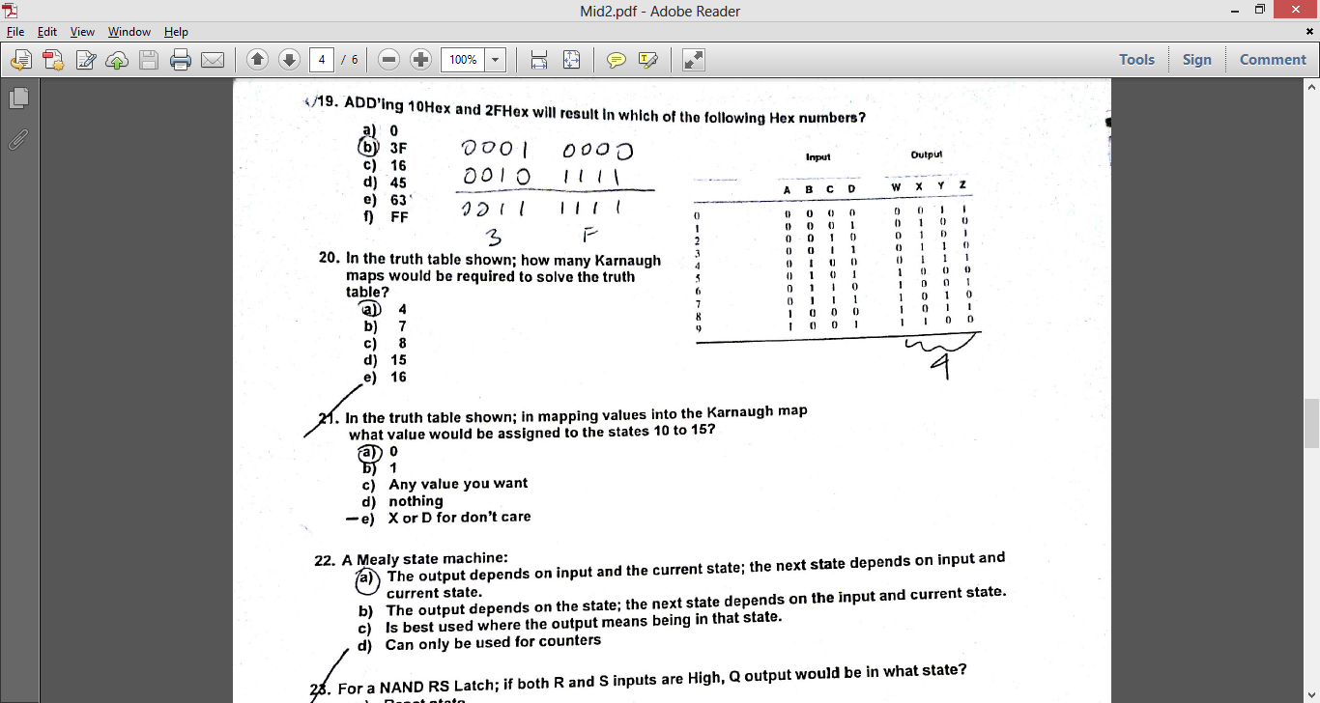
    1. 4
13. In the truth table shown; in mapping values into the Karnaugh map what value would be assigned to the states 10 to 15?
    1. X or D for don’t care
14. A Mealy state machine:
    1. The output depends on input and the current state; the next state depends on input and current state.
15. For a NAND RS Latch; if both R and S inputs are low, Q output would be in what state?

a. Undefined state

1. For a NAND RS Latch; if both R and S inputs are High, Q output would be in what state?
2. XNOR’ing 2FHex and 10Hex will result in which of the following Hex numbers?
   1. 0
3. Given a 4 bit adder with carry out, S4, adding two four bit numbers A and B. If A = 7 and B = 8, what would the values of S4, S3, S2, S1, S0 be?
   1. 01111
4. be used for the function, F = /AB + A/B?
   1. XOR
5. For a NOR RS Latch, if both R and S inputs are High, Q output would be in what state?
   1. Undefined state
6. In 8 to 1 Multiplexer shown, with A = 0, B = 1, C = 1; what would the value of output Y be equal to?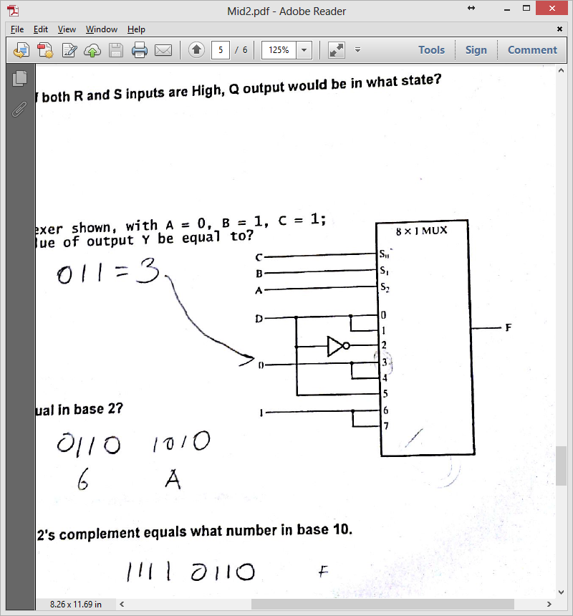
   1. 0
7. What would 6A Hex equal in base 2?
   1. 0110 1010
8. The number F6Hex in 2’s complement equals what number in base 10.
   1. - 10
9. If S1 = 1, R1 = 0, S2 = 1, R2 = 0, S3 = 0, R3 = 1, S4 = 1, R4 =0; what is the output of the counter in hexadecimal.

a.2 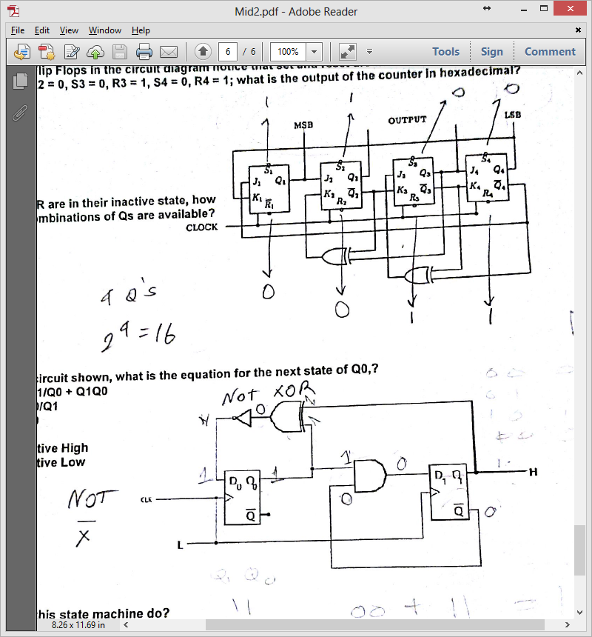

1. For the Flip Flops in the Circuit diagram notice that set and reset are active low. If S1 = 1, R1 = 0, S2 = 1, R2 = 0, S3 = 0, R3 = 1, S4 = 0, R4 = 1; what is the output of the counter in hexadecimal.
   1. 3
2. If S and R in their inactive state, how many combination of Qs are available?
   1. 16
3. For the circuit shown, what is the equation for the next state of Q0,?
   1. /Q1/Q0 + Q1Q0
4. What will this state machine do?
5. What will this circuit do?
   1. Divide by 3
6. If Q1 is 1 and Q0 is 1, what is the next state of Q1 and Q0?
   1. 00
7. Using the Karnaugh map for minimum gates, would result in which of the following equations: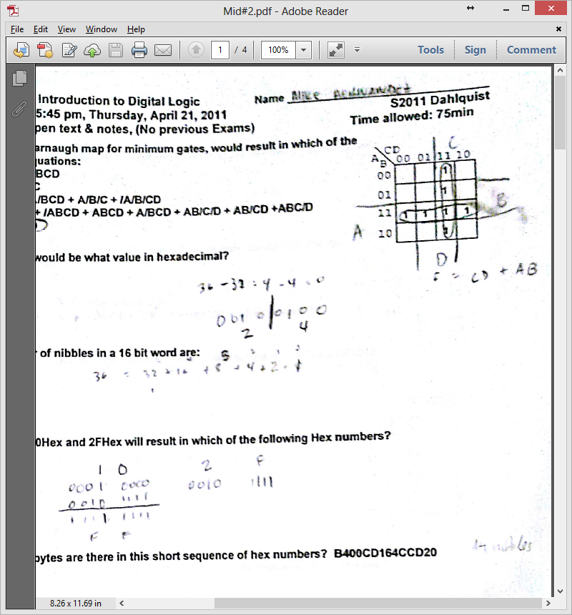
   1. AB + CD
8. 36 decimal would be what value in hexadecimal?
   1. 24
9. NAND’ing 10Hex and 2FHex will result in which of the following Hex numbers?
   1. FF
10. How many bytes are there in this short sequence of hex numbers? **B400CD164CCD20**
    1. 7

How many bytes are there in this short sequence of hex numbers? B400CD16CD20

A= 6 ( divide that by 2)

1. How many nibbles are there in this short sequence of hex numbers? B400CD164CCD20
   1. 14
2. Using Karnaugh map for the least gates, would result in which equation?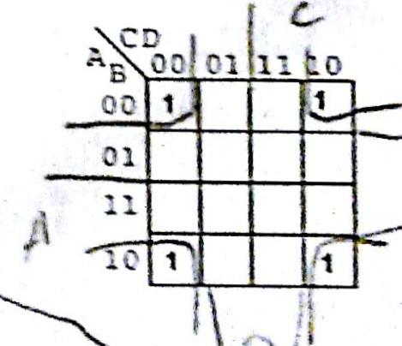
   1. /B C/D + /B/C/D
3. How many bits would be required to count for 0 to 1024 in binary?
   1. 10
4. AND’ing 8FHex and 02Hex will result in which of the following Hex numbers?
   1. 02
5. Which of the following equations were sued to map the values into the Karnaugh map?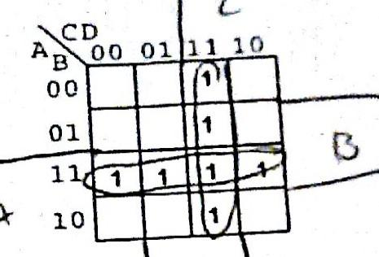
   1. /A/BCD + /ABCD + ABCD + A/BCD + AB/C/D + AB/CD + ABC/D
6. How many bits are there in this sequence of hex numbers? **B400CD16CD20**
   1. 48
   2. Count all characters
7. In 8 to 1 Multiplexer show, if A = 0, B = 1, C = 1; what would the output be equal to? 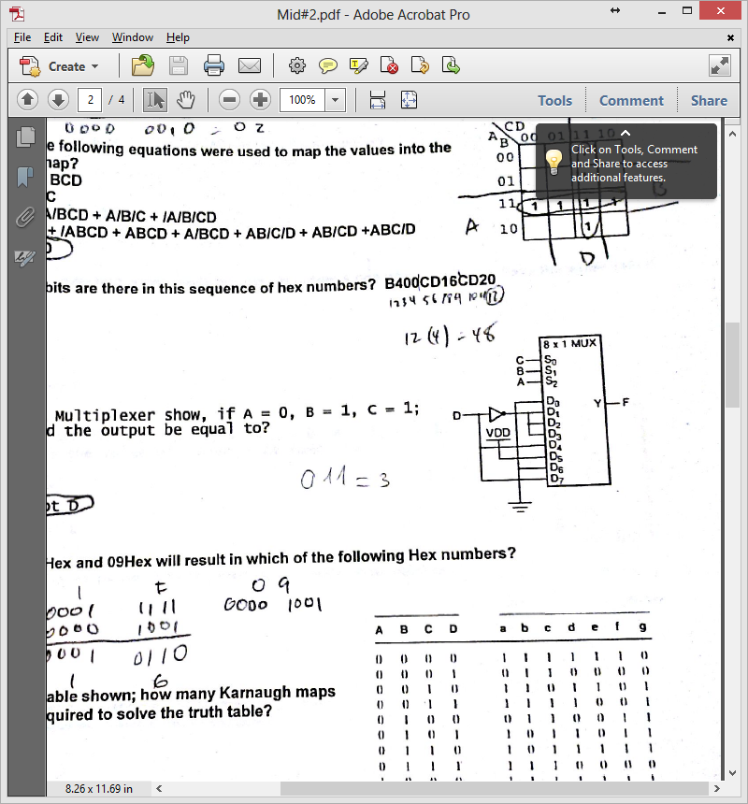
   1. Not D (/D)
8. XOR’ing 1FHex and 09Hex will result in which of the following Hex numbers?
   1. 16
9. In the truth table shown; how many Karnaugh maps would be required to solve the truth table?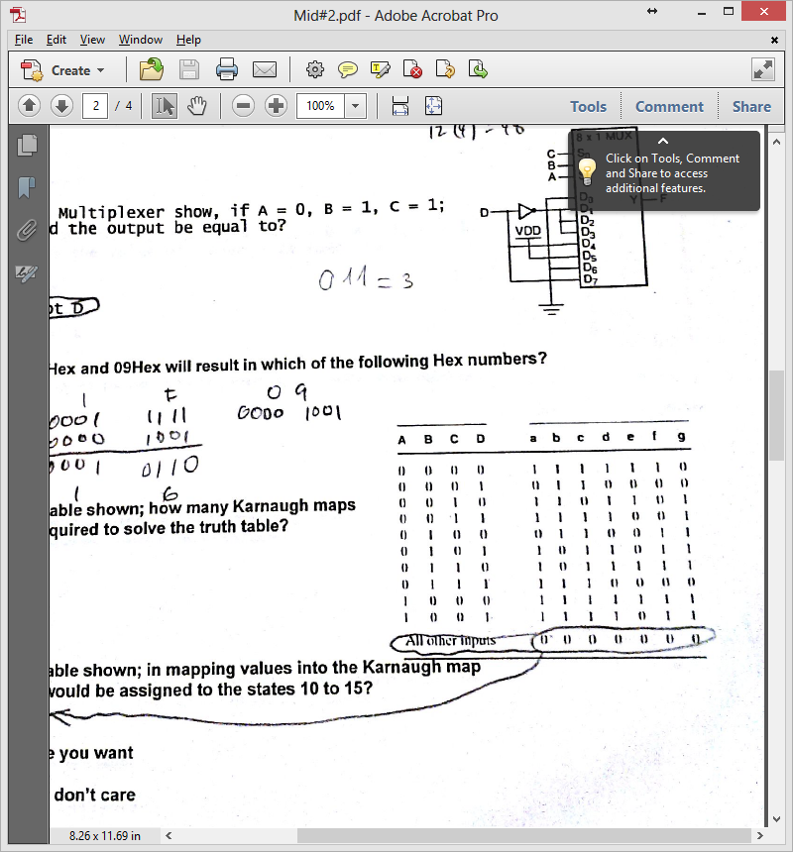
   1. 7
10. In the truth table shown; in mapping values to Karnaugh map what value would be assigned to the states 10 to 15?
    1. 0
11. For the Karnaugh map shown, what equation was used to maps the ones into the map?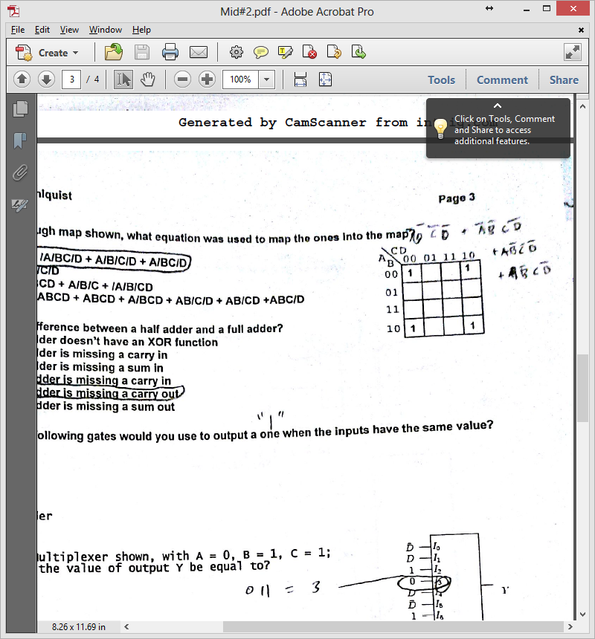
    1. /A/C/B/D + /A/BC/D + A/B/C/D + A/BC/D
12. Which of the following gates would you use to output a one when the inputs have the same value?
    1. XNOR
13. In 8 to 1 Multiplexer show, if A = 0, B = 1, C = 1; what would the output be equal to?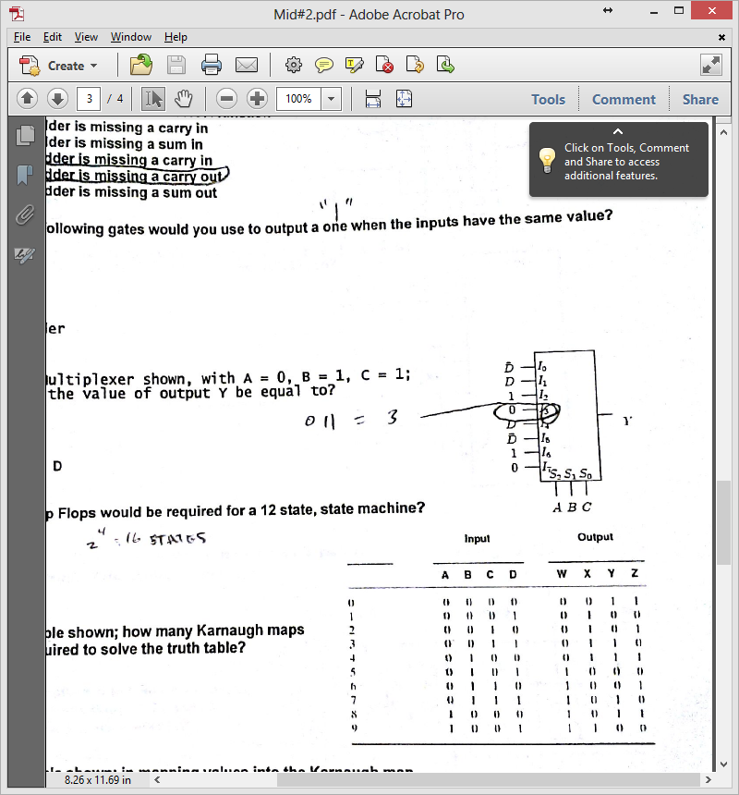
    1. 0
14. How many Flip Flops would be required for a 12 state, state machine?
    1. 4
15. A “pull down” resistor is used in digital circuits to do what?
    1. To keep the signal line “tied” low until the line is active (goes high)
16. Using the Karnaugh map for the least number of gates, what would the final equation be?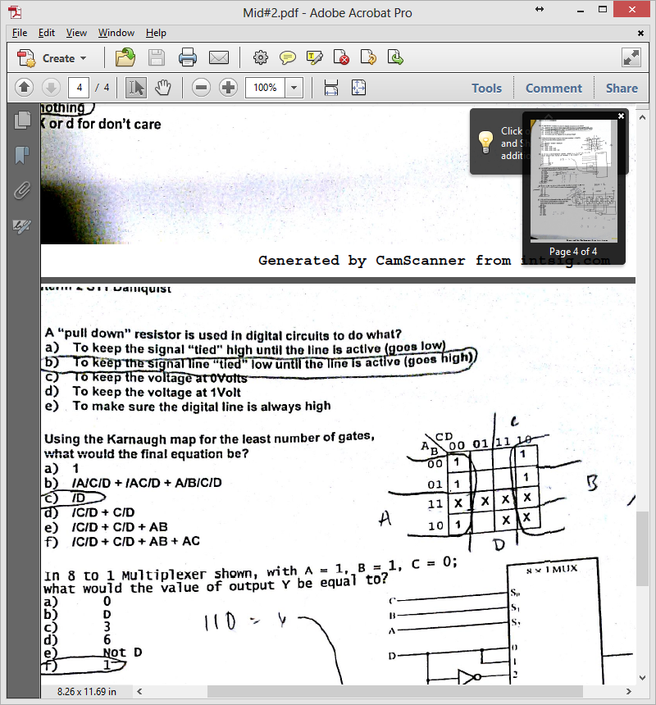
    1. /D
17. In 8 to 1 Multiplexer, show, if A = 1, B = 0, C = 0; what would the value of output Y be equal to? 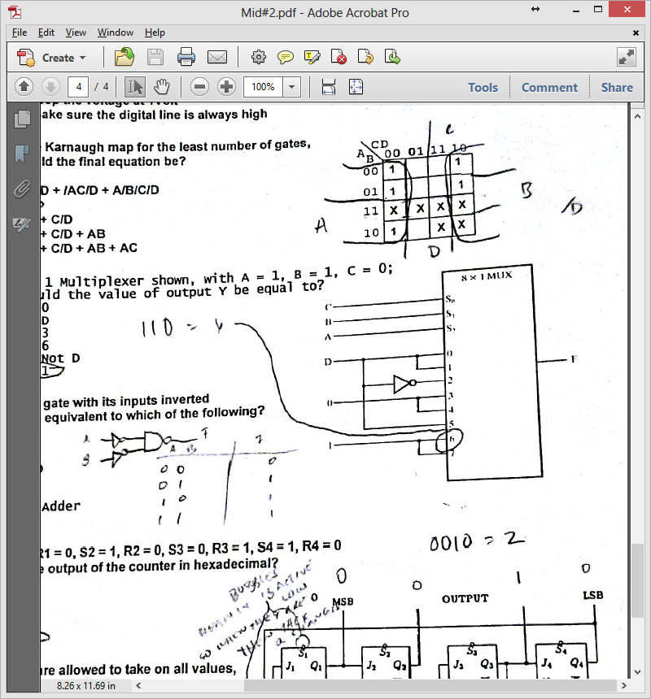
    1. 1
18. An NAND gate with its inputs inverted would be equivalent to which of the following?
    1. OR
19. If S1 = 1, R1 = 0, S2 = 1, R2 = 0, S3 = 0, R3 = 1, S4 = 1, R4 = 0; what is the output of the counter in hexadecimal.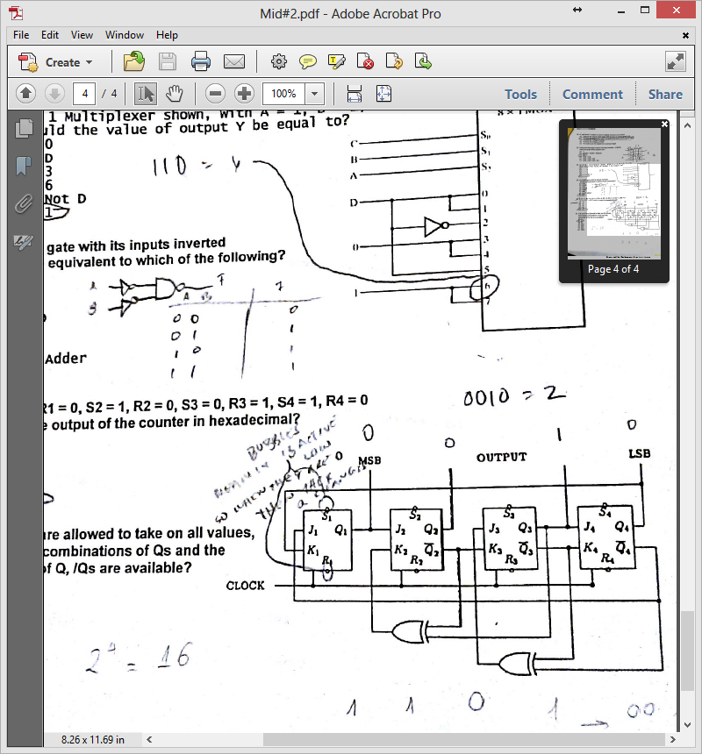
    1. 2
20. If S and R are allowed to take on all values, how many combinations of Qs and the Next state of Q, /Qs are available?
    1. 16
21. How many Flip Flops would be required for a 9 state, state machine
    1. 4
22. If 10Hex is XOR’ing with 2FHex would result in which of the following Decimal numbers?
    1. 63 decimal
    2. B.3f hex
23. For a NOR RS Latch, if both R and S inputs are Low, Q output would be in what state?
    1. No change
24. The number of bytes needed for a 32 bit number are:
    1. 4
25. How many bits would be required to count from 0 to 1023 in binary?
    1. 10
26. What is the signed decimal value of the hex number, FFF0
    1. -16
27. If 10Hex is ADDed to 2FHex would result in which of the following Hex numbers?
    1. 3F
28. In 8 to 1 Multiplexer, show, if A = 1, B = 0, C = 0, D = 0; what would the output be equal too?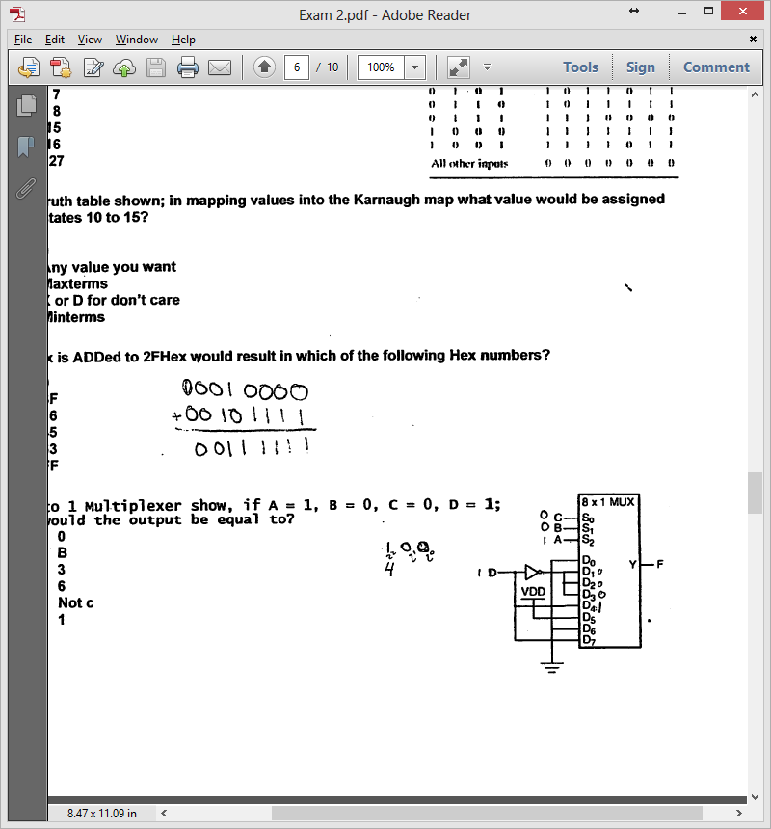
    1. 1
29. Given a 4 bit adder with carry out, S4, adding two four bit numbers A and B. If A = 8 and B = 8, what would the values of S4, S3, S2, S1, S0 be?
    1. 10000
30. What would 6A Hex equal in base 10?
    1. 106

1. For the circuit shown, what is the equation for the next state of Q1,?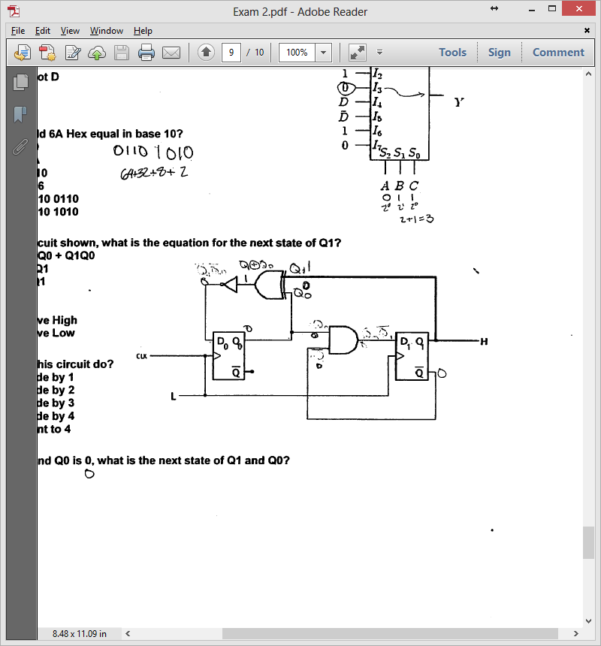
   1. Q0/Q1
2. What will this circuit do?
   1. Divide by 3
3. If Q1 is 1 and Q0 is 0, what is the next state of Q1 and Q0?
   1. 00
4. The number F6Hex in 2’s complement equals what number in base 16.

a.–A

1. In 8 to 1 Multiplexer show, if A = 1, B = 0, C = 1; what would the output be equal to?
2. d
3. In 8 to 1 Multiplexer show, if A = 1, B = 1, C = 1; what would the output be equal to?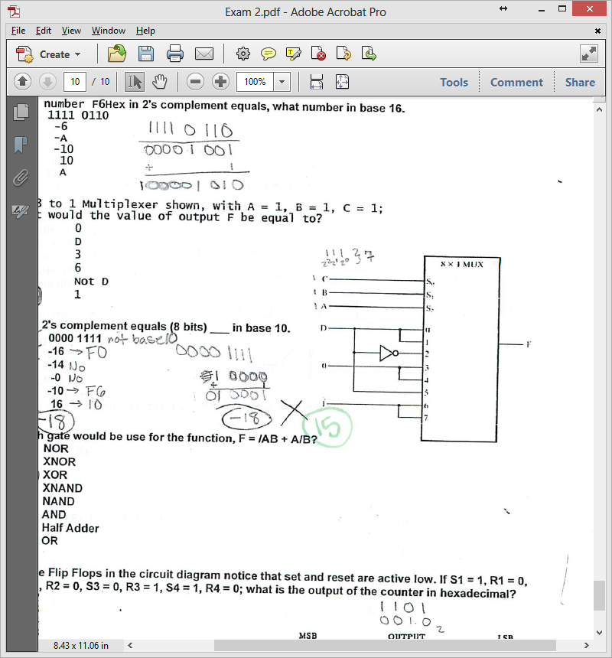
   1. 1
4. 0F in 2’s complement equals (8 bits) ____ in base 10.
   1. 15
5. For the Flip Flops in the Circuit diagram notice that set and reset are active low. If S1 = 1, R1 = 0, S2 = 1, R2 = 0, S3 = 0, R3 = 1, S4 = 1, R4 = 0; what is the output of the counter in hexadecimal.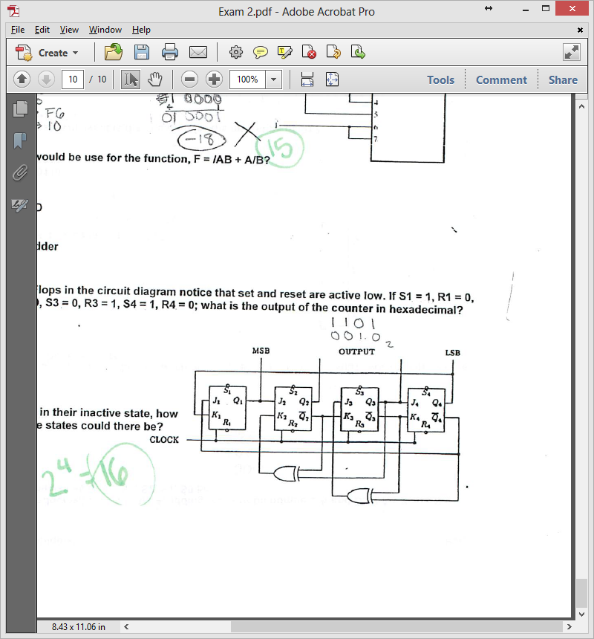
   1. 2
6. If S and R are in their inactive state, how many possible states could there be?
   1. 16
7. Using the Karnaugh map, would result in which of the following equations: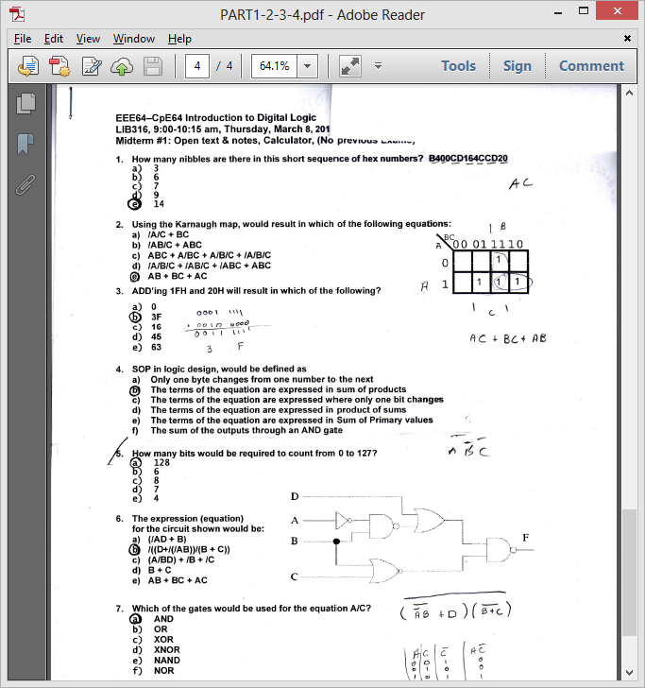
   1. AB+BC+AC
8. ADD’ing 1FH and 20H will result in which of the following?
   1. 3F
9. SOP in logic design, would be defiend as
   1. The terms of the eqution are expressed in sum of products.
10. The expression (equation) for the circuit shown would be: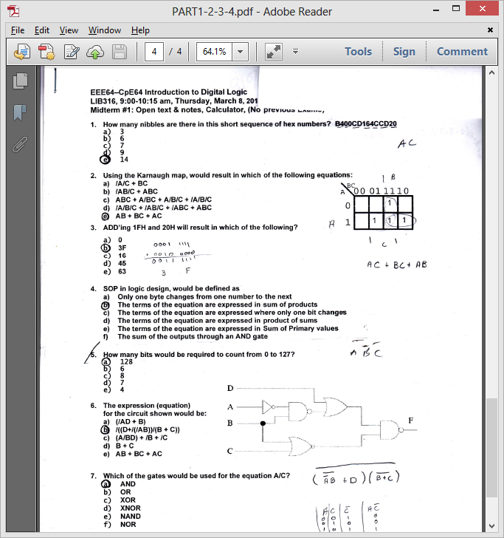
    1. /((D+(AB))/(B+C))

1. Which of the gates would be sued for the equation A/C
   1. AND
2. The equation F = ABD + CD + /C/D would be equivalent to which of the equations?
   1. (B + C + /D)(A + C+ /D)(/C + D)
3. The binary value 1111 0110 in 2’s comlplement equations _____ in base 10.
   1. -10
4. The number of bits in a Byte are:
   1. 8
5. Gray code, would be a code where
   1. Only one bit changes form one number to the next
6. The equation for F(A,B,C) in the diagram would be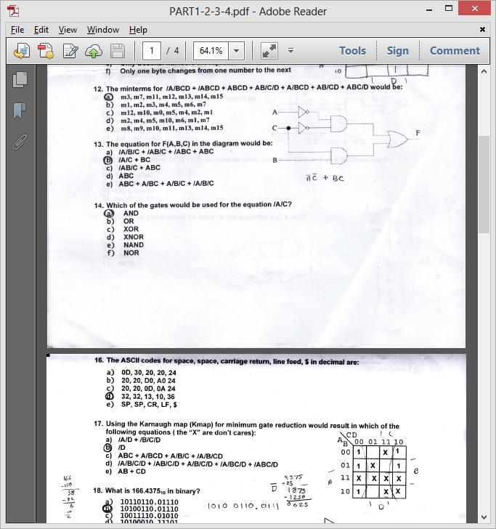
7. The minimum equation for F(A,B,C) in the diagram would be
   1. /A/C + BC
8. Which of the following gates would be used for the equation /A/C
   1. AND
9. 24 hex would be what value in decimal?
   1. 36
10. The ASCII codes for space, space, carriage return, line feed, $ in decimal are:
    1. 32, 32, 13, 10, 36
11. Using the Karnaugh map (Kmap) for minimum gate reduction, would result in which of the following equations (the “X” are don’t cares): 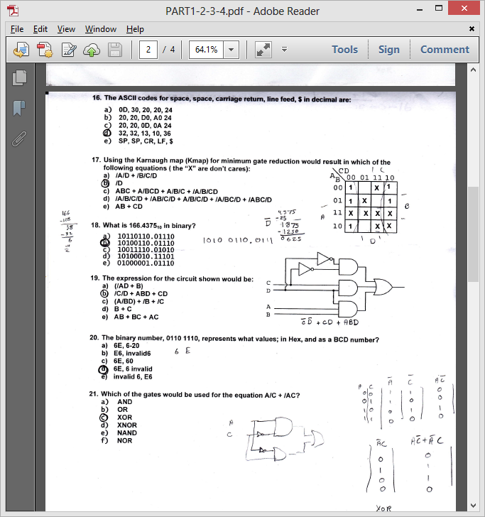
    1. /D
12. What is 166.437510 in binary
    1. 10100110.01110
13. The expression for the circuit shown would be:
    1. /C/D + ABD + CD
14. The binary number, 0110 1110, represents what values; in Hex, and as a BCD number?
    1. 6E, 6 invalid
15. What is the signed decimal value of the hex number, 0F in 8bits?
    1. 15
16. Minimizing /A/B + /AB + AB would result in:
    1. /A + B
17. Minimizing the equation /A/BCD + /ABCD + ABCD + AB/C/D + A/BCD + AB/CD + ABC/D would result in:
    1. AB + CD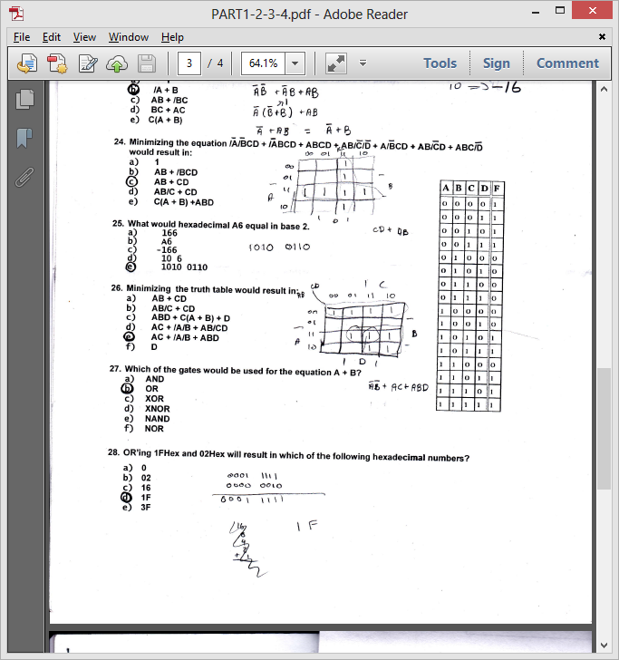
18. What would hexadecimal A6 equal in base 2?
    1. 1010 0110
19. Minimizing the truth table would result in:
    1. AC + /A/B + ABD
20. Which of the gates would be used for the equation A + B?
    1. OR
21. OR’ing 1FHex and 02Hex will result in which of the following hexadecimal numbers?
    1. 1F
22. The equation used to populate Karnaugh map, would be which of the following equations? 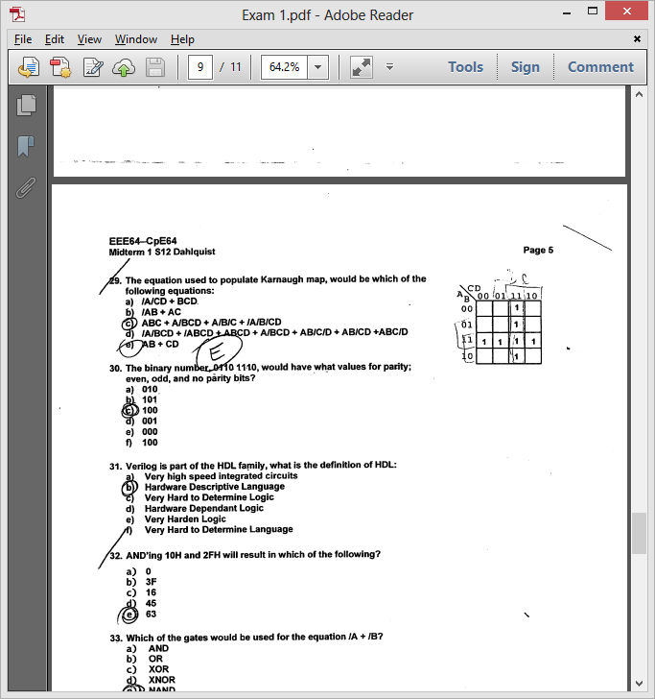
    1. AB + CD
23. The binary number, 0110 1110, would have what values for parity; even, odd, and no parity bits?
    1. 100
24. Verilog is part of the HDL family, what is the definition of HDL
    1. Hardware Descriptive Language
25. Which of the gates would be used for the equation /A + /B?
    1. NAND
26. Reducing F = /ABC + A/BC + AB/C + ABC
    1. AC+AB+BC
27. Using the Karnaugh map for minimum gate reduction would result in | which of the following equations?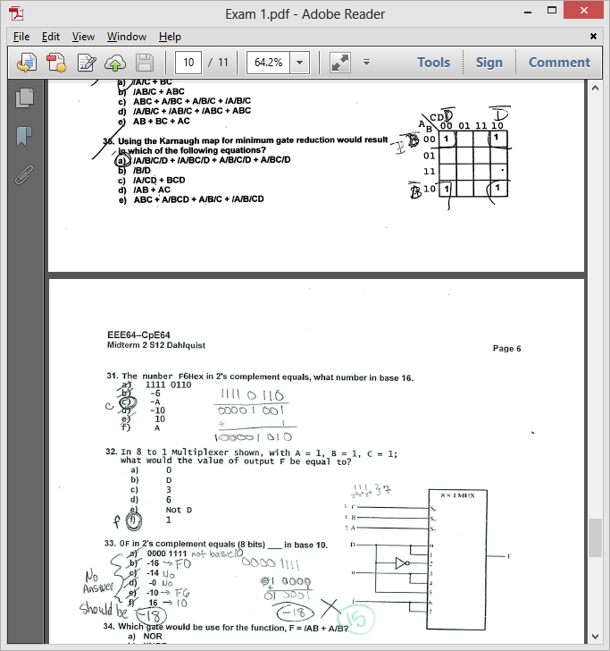
    1. /B/D
28. AND’ing 10H and 2FH will result in which of the following?
    1. 0

110.1 AND’ing 1FH and 20H will result in which of the following?

a. 0

1. How many bits would be required to to count from 0 to 127?
   1. 7

112. How many nibbles are there in this short sequence of hex numbers?   
 B400CD164CCD20

a. 14.

113. SOP in logic design, would be defined as

a. The terms of the equation are expressed in .sum of products.

115. which of the gates would be used for the equation A/C

a. AND

116 The equation F =ABD + CD+ /C/D would be equivalent to which of the equations?

1. B+C+/D)(A+C+/D)(/C+D)

117. The binary value 1111 0110 in 2’s compliment equals _ in base 10

a. -10

118. The number of bits in a Byte are

a. 8

118. The number of bits in a double word are:

64 and word is 32 half word 16

119. Gray code, would be a code where

a. Only one bit changes from one number to the next

120. The minterms for /A/BCD + /ABCD + ABCD + AB/C/D +AB/CD+ ABC/D would be:

a. m3,m7,mll,m12,m13,m14,ml5

120 The minterms for /A/B/CD + /A/BC/D + /A/BCD +/AB/C/D +/AB/CD+ A/B/C/D would be:

a. m1,m2,m3,m4,m5,m6,m7

121. Which of the gates would be used for the equation /A/C

a. nor

122. The ASCII codes for space, space, carriage return, line feed $ in decimal are:

a. 32,32, 13,10,36

123. What is 166.437510 in binary?

a. 10100110.01110

124. The binary number , 0110 1110, represents what values; in Hex, and as a BCD number?

a. 6E, 6 invalid

124. The binary number , 0100 1110, represents what values; in Hex, and as a BCD number?

a. 4E, 4 invalid

125. 21 . Which of the gates would be used for the equation A/C + /AC?

a) XOR

126. What is the signed decimal value of the hex number, OF in 8 bits?

a) 15

127. Minimizing /A/B + /AB + AB would result in:

a. /A + B

128. What would hexadecimal A6 equal in base 2

a. 1010 0110

129. OR'ing 1FHex and 02Hex will result in which of the following hexadecimal numbers?

a. 1F

131. Reducing F =/ABC + A/BC + AB/C +ABC would result in the equation:

a. AB + BC + AC

132. AND'ing 10H and 2FH will result in which of the following?

a. 0

133. 30. The binary number, 0110 1110, would have what values for parity; even, odd, and no parity bits?

a. 100

134. If 10hex is XNOR with 2FHex would result in which of the following decimal numbers

a. c0 hex

b. 0 dec

135. in the truth table shown ; in mapping values into the karnaugh map what value would be assigned to the states A to F

a. X or d for don’t care

135. 1010 0110 in 2’s complement equals ____ in base 10.

a. -90

137. What is the decimal value of hex number,E0 in 2’s compliment?

a.-32

138.10 hex is added with 2FHEx would result in witch of following decimal numbers?

a. 63

139.A NOR gate with its inputs inverted would be equivalent to which of the following?

a. and

140. If 10Hex is ADDed to 2FHex would result in which of the following decimal number?

a.63

141. Given 4 bit adder with carry out, s4, adding two four bit numbers A and B. If A=8 and B = 8, what would the value of s4, s3,s2,s1,s0 be?

a.10000

142. If 10Hex is NANDed with 2FHex would result in which of the following hexdecimal numbers?

a.FF

143. AND’ing 8FHex and 02Hex will result in which of the following Hex numbers?  
a.02

144. Which of the following gates would you use to output a one when the inputs have the same value?

a. XNOR

145. Given a 4 bit adder with carry out, s4, adding two four bit numbers A and B. If A=15 and B=15, what would the values of s4,s3,s2,s1,so be?

a. 11110

146. Given a 4 bit adder with carry out, S4, adding two four bit numbers A and B. If A = 8 and B = 7, what would the values of S4, S3, S2, S1, S0 be?

a.01111

147. If 09Hex is XORed With 1FHex would result it which of the following hexadecimal numbers?

a. 16

148) In 8 to 1 multiplexer show, if A=1, B=0, c=0, D=1; what would the output be equal to ?

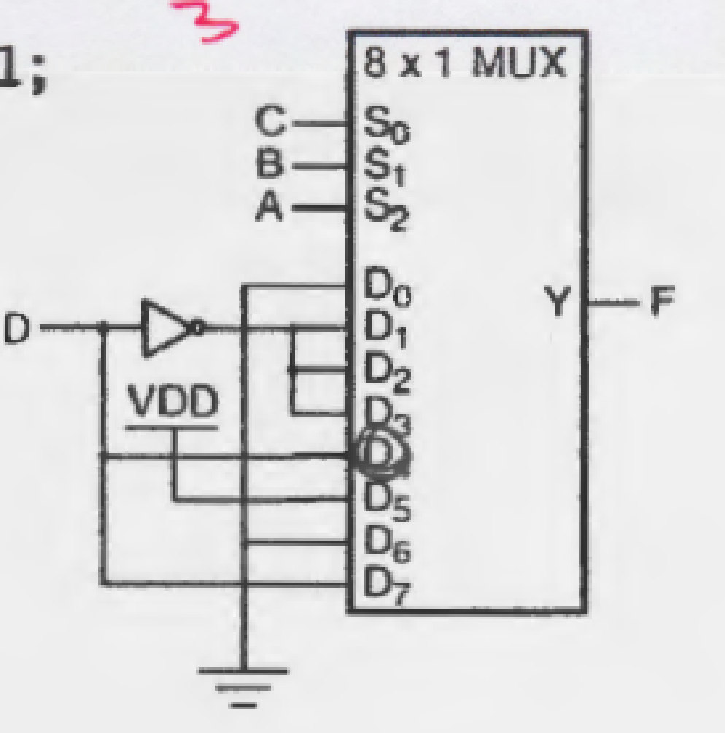

1. Answer = 1

149. For a D Flip Flop with active low preset and clear, the D input set to 1 , Present to 0, and clear set 0. What will Q be on the next clock pulse?

a. Undefined or invalid state

150. For a Nor RS Latch; if R and S inputs are both low, the inputs would be in what state?

a. Previous or latched state

151. For a NOR RS Latch; if R is low and S is high, Q output would be in what state?

a. set state

152. a D Flip Flop with active low preset and clear, the D input set to 0,Present set to 1 and clear set to 1. What will Q be on the next clock pulse?

a.0

153. For a NAND RS Latch; if both R and s inputs are High, Q output would be in what state?

a. Previous or latched state

154. For a NAND RS Latch; if R is low and S is High, Q output would be in what state?

a. reset state

155 For a D Flip Flop with active low preset and clear, the D input set to 1,present set to 1, and Clear set to 0. What will Q be on the next clock pulse?

1. 1

156. For a D Flip Flop with active low preset and clear, the D input set to 1,preset set to 1, and Clear set to 1. What will Q be on the next clock pulse?

a.1

157. If 0001 0000 binary is XORed with 0010 1111 binary would result in which of the following binary numbers?

a. 0011 1111

158. with 7 inputs how many binary combinations would there be most nearly in decimal ?

a. 128

159. POS in logic design, would be defined as:

1. The terms of equation are expressed in product of sum

160. Twos complement is where:

a. Negative numbers are represented

**EEE-174 MT1**

1. What is the hexadecimal encoding for "JNL" for a jump back 8 bytes?

answer

2. In X86 architecture, ALU stands for which of the following?

Arithmetic Logic Unit

3. The number of nibbles in a word are:

16/4 = 4

4. The instruction MOV BX, [2BAD] is what addressing mode?

Direct

5. What is the hexadecimal encoding for adding DX with BX and storing the result in BX?

?????

6. A microprocessor with a 32-bit address bus could access how much memory?

2^4=16MB , 2^8=256KB, 2^32=4GB

7. You add 7+6 through a 4 bit integer unit. The state of the OF and CF flags after the add will be:

0111 1 OF=1, the sign bit has changed

+0110 CF=1,the0118**13A7:0110**re is a carryon of bit 7

0|1101

8. Which of the following DOS Debug instructions would be used change the IP register to 100?

RIP

9. What are the contents of CX after this program has been run:

|  |  |
| --- | --- |
| Memory location | Contents |
| 5514 | 24 |
| 5513 | D8 |
| 5512 | 00 |
| 5511 | 21 |

MOV DX, 11h

MOV CX, [5512]

MOV BX, 5511h

SUB DX, [BX]

D800h

***What are the contents of DX after this program has been run:

FFF0h

10. Given:

AX=FFD0 BX=3534 CX=0000 DX=0180 SP=FFEE BP=0000 SI=0000 DI=0000

DS=1D72 ES=1D72 SS=1D72 CS=1D72 IP=0109 OV UP EI PL NZ NA PO CY

1D72:0109 7D06 JNL 0118

What is the signed decimal value of the number in the AX register?

-48

11. How many bytes are there in this short sequence of code? B815B400CD16CD20

8

12. In using INT 10h to set the video code to 640x350,what value must be in the AH register?

AX

AH|AL

00

00h

13. Moore's law has accurately predicted the growth rate in the number of transistors per die for the last 25 years. What is that rate?

Doubling every 18-24 months

14. INT 21h, Function 09h requires three things set up before calling in order to correctly print a string,

Hello_msg. They are:

DS=SEG Hello_msg, DX=OFFSET Hello_msg, Hello_msg terminated with 24h

15. Given

13A7:0110 CD 20 32 20 54 68 69 73-20 69 73 20 74 68 65 20

13A7:0120 66 69 72 73 74 20 4D 69-64 75 65 72 6D 0D 24 D9

13A7:0130 00 C6 00 00 00 00 00 00-00 00 00 00 00 00 00 00

An input buffer is at memory location 0112, what is the size of the buffer in decimal?

50

16. Here is a short sequence of code: 7413CD16EB157D213C04EBF0A3C6. All of the instructions are two bytes long. The third instruction operator is: EB15

JMP

17. What is the hexadecimal encoding for loading DX with a word (value) from memory location 0820h?

8B162008

18. Given:

AX=FFE0 BX=3534 CX=0000 DX=0180 SP=FFEE BP=0000 SI=0000 DI=0000

DS=1D72 ES=1D72 SS=1D72 CS=1D72 IP=010D OV UP EI PL NZ NA PO NC

1D72: 010D 7D09 JGE 0116

How many bytes will the processor jump if the condition for a jump were met?

9

19. F6 in 2's complement equals _______in base 10.

10

20. Given:

AX=FFD0 BX=3534 CX=0000 DX=0180 SP=FFEE BP=0000 SI=0000 DI=0000

DS=1D72 ES=1D72 SS=1D72 CS=1D72 IP=010D OV UP EI NG NZ NA PO NC

1D72: 010D 7D09 JNLE 0116

What will the IP value be after a "t" command is executed in DOS Debug?

??????

21. Determine the contents of register BH after the following instructions have executed:

70h MOV [0202], AX

22. Given:

AX=2247 BX=0000 CX=0000 DX=0000 SP=FFEE BP=0000 SI=0000 DI=0000

DS=1D72 ES=1D72 SS=1D72 CS=1D72 IP=0106 NV UP EI NG NZ NA PE NC

1D72: 0106 EB0F JMP 0118

What will be the IP value be after a "t" command is executed in DOS Debug?

0118h

23. Which of the following DOS Debug instructions would set a break point at memory location 010E?

G=100 10E

24. Given:

0B0E: 0200 57 65 6C 63 6F 6D 65 20-74 6F 20 41 73 73 65 6D

0B0E:0210 62 6C 79 20 4C 61 6E 67-75 61 67 65 00 00 00 00

An ASCII message begins at memory location 0200, what is the message?

Welcome to Assembly Language

25. Given:

AX=FF47 BX=0000 CX=0000 DX=0000 SP=FFEE BP=0000 SI=0000 DI=0000

DS=1D72 ES=1D72 SS=1D72 IP=0104 NV UP EI NG NZ NA PE NC

1D72:0104 7002 JO 0118

What will the IP value be after a "t" command is executed in DOS Debug?

0106h

26. Given:

AX=FFD0 BX=3534 CX=0000 DX=0180 SP=FFEE BP=0000 SI=0000 DI=0000

DS=1D72 ES=1D72 SS=1D72 CS=1D72 IP=010E OV UP EI PL NZ NA PO CY

1D72:0109 7D06 JNL 0118

What will the IP value be after a "t" command is executed in DOS Debug?

0110

27. The instruction MOV BX, 2BAD is what addressing mode?

Immediate

28. What is the hexadecimal encoding for "JNL" for a jump back 10 bytes?

7DF4

29. How many address lines would be required to address 64MB directly?

26 /2^26=67mb/

30. The number of nibbles in a double word are: 8

31. In using INT 10h to move the screen cursor to return on the same line, what value must be in the AX register?

0E0Dh

32. Given:

AX=FFD0 BX=3534 CX=0000 DX=0180 SP=FFEE BP=0000 SI=0000 DI=0000

DS=1D72 ES=1D72 SS=1D72 CS=1D72 IP=010D OV U EI PL NZ NA PO NC

1d72: 010D 7D09 JNLE 0118

What will the IP value be after a "t" command is executed in DOS Debug?

010Fh

33. Which of the following DOS Debug instructions would be used change the AX register?

RAX

34. How many Bytes are there in this short sequence of code? B815B400CD168A3CCD20

10

35. Given:

AX=FFD0 BX=3534 CX=0000 DX=0180 SP=FFEE BP=0000 SI=0000 DI=0000

DS=1D72 ES=1D72 SS=1D72 CS=1D72 IP=0111 NV UP EI NG NZ NA PO CY

1D72:0111 EB08 JMP 0119

What will the IP value be after a "t" command is executed in DOS Debug?

0119h

36.Given:

AX=FFD0 BX=3534 CX=0000 DX=0180 SP=FFEE BP=0000 SI=0000 DI=0000

DS=1D72 ES=1D72 SS=1D72 CS=1D72 IP=010E OV UP EI NG NZ NA PO CY

1D72: 010E 7D06 JNLE 0118

What will the IP value be after a "t" command is executed in DOS Debug?

0118

37. How many bytes decimal will the program jump for JNB instruction, given the following?

AX=0000 BX=0000 CX=0000 DX=0000 SP=FFEE BP=0000 SI=0000 DI=0000

DS=1376 ES=1376 SS=1376 CS=1376 IP=0100 NV UP EI PL NZ NA PO NC

1376:0100 73E0 JNB 00E2

-32

38. Given:

AX=FFE0 BX=3534 CX=0000 DX=0180 SP=FFEE BP=0000 SI=0000 DI=0000

DS=1D72 ES=1D72 SS=1D72 CS=1D72 IP=010D OV UP EI PL NZ NA PO NC

1D72: 010D 7F09 JNLE 0118

What is the decimal value of the signed number in the AX register?

-0032

39. How many address lines would be required to address 512 MB directly?

29 /2^9=29/

40. What is the hexadecimal encoding for adding BX with CX and storing the result in BX?

03D9

41. The binary number, 0111 1110, represents what values; in Hex, and as a BCD number?

7E, 7 invalid

42. In using INT 10h to set the vidio mode to 640 X 200, what value must be in the AX register?

0006h

43. what is the hexadecimal encoding for loading AH with a word from memory location 0520h?

8A262005

44. What is the hexadecimal encoding for "JGE" for a jump back 10 bytes?

7DF6

45. Given:

13A7:0110 CD 20 48 20 54 68 69 73-20 69 73 20 74 68 65 20

13A7:0120 66 69 72 73 74 20 4D 69-64 74 65 72 6D 0D 24 D9

13A7:0120 00 C6 00 00 00 00 00 00-00 00 00 00 00 00 00 00

An input buffer is at memory location 0112, what is the size of the buffer in bytes in decimal:

72

46. Given:

AX=FF47 BX=0000 CX=0000 DX=0000 SP=FFEE BP=0000 SI=0000 DI=0000

DS=1D72 ES=1D72 SS=1D72 CS=1D72 IP=0106 NV UP EI NG NZ NA PE NC

1D72:0104 7002 JNO 0118

What will the IP value be after a "t" command is executed in DOS Debug?

0118

47. Determine the contents of register AH after the following instruction have executed:

MOV BX,BA70H

MOV AX,47E7H

MOV BL, 0FH 47H

AND AL,BL

MOV [0202], AX

48. In using INT 10h to move the screen cursor to return to the beginning of the line, what value must be in the AX register?

0E0Dh

49. Given:

1376:0110 48 61 76 65 20 61 20 67-72 65 61 74 20 53 70 72

1376:0120 69 6E 67 20 52 65 63 65-73 73 21 00 00 00 00 00

An ASCII message begins at memory location 0110, what is the message?

Have a great Spring Recess!

50. You add 1+8 through a 4 bit integer unit. The state of the OF and CF flags after the ad will be:

OF=0, CF=0

Page 16

51. What is the advantage of Assembly Language over C Language?

The Assembler creates much faster executable code

52. In The X86 lab 3 Hello MASM program in the original code, what is the address of the byte used to start the number in the sequence "Hello World 0"?

020E

53. Which of the following DOS Debug instructions would set a break point at memory location 010C?

G = 100 10C

54. If CX is 0000 what will CX be after a "LOOP" instruction?

FFFF

55. Given:

AX=0353 BX=0534 CX=0000 DX=0180

DS= 1D72 IP=0109 OV UP EI PL NZ NA PO CY

1D72:0109 7D06 (OV=1,NV=1 ZR=1, NZ=0)

010B

56. How many core does the propeller microcontroller have?

8

57. What is the hexadecimal encoding for "JGE" for a jump back 12 byes?

7DF2

58.Here is a short sequence of code: 7413EBA3CD167D213C04EBF0EB15. instructions are a word long. The third instruction operator is:

INT

59. In MASM, with a "MOV CX, 24" instruction, and a "LOOP" instruction, in decimal how many times will the program loop?

24LATD LED output

60. The ASCII codes for space , space, carriage return, line feed, end of string in decimal are:

32,32,13,10,36

61. A "NOP" instruction in a program will:

Perform a No Operation

62. How many address lines would be required to address 64MB directly?

26

63. What command in DEBUG would be used to execute interrupts?

P

64. What high level language is the propeller programmed in?

Spin0 to 9**TRISD = 0b01111111**

65. Which of the following DOS Debug instruction would be used to change the IP register to 010C?

RIP

66. The acronym PWM used in the Parrallax Propeller and MicroChip PIC18, is defined as:

Pulse Width Modulation

67. Which command would you use to execute another core in the propeller microcontroller?

Cognew

68. Given: IP=0111 NV UP EI NG NZ NA PO CY

1D72:0111 JMP 0119

What will the IP value be after a "t" command is executed in DOS Debug?

0119h

69. The instruction MOV CX, DADD is what addressing mode?

Immediate

70. In the PIC18 with TRISD = 0b00001111 and LATD = 0xAA, what value will be on Port D and shown on the LEDs?

A0

71. In the Propeller microcontroller, the command "dira[4..9] := %111111" would cause the processor to do with of the following?

Sets the Propeller pins P4 through P9 as output pins

72. In the Propeller microcontroller, the command "waitcnt(clkfreq*10 + cnt)" would cause the processor to do with of the following?

Create 10 second delay

73. The "LOOPNE" instruction is equivalent to which of the following instructions?

DEC CX, JNE

74. On the Arduino platform, what is the programming language used?

C

How many bit(s) is/are required to represent a range of decimal numbers from 0 to 9?

1. 4

A “POP” instruction:

1. increments the Stack Pointer, SP

The instruction MOV CX, SI is what addressing mode?

1. Immediate

Which of the following will cause a program with a LOOP instruction to loop 48 times (decimal)”

1. ***CX = 30h***

A “PUSH” instruction:

1. Decrements the SP/increments the IP

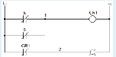

The Ladder Logic diagram would represent which of the following?

1. AND

If you want to use a INT software interrupt function to print a string out to the screen, what is the function code, start pointer, termination character, and interrupt you need to use?

Select one:

1. ah = 09h, ds:dx, “$”, 21h

You are trying to rebuild a HELLO project program in MASM and you get the following error: “LINK: fatal error L1089: HELLO.lrf: cannot open response file”.

What would be the reason for such an error?

Select one:

1. No source file is identified (no.asm file)

The instruction MOV SI, 4DAD is what addressing mode?

Select one:

1. Immediate

How many nibble are in double precision IEEE floating point format numbers (64bit)?

Select one:

1. 16

What flag(s) does the “LOOPNE” instruction look at to determine whether to loop or not?

1. CX

What is the numeric sequence of the key pad columns on the PPE board?

Select one:

1. 37,2F,1F

18 hexadecimal would be what value in decimal?

1. 24

In the PIC 18 with TRISD = 0b01000000, what is the configuration of the Port D?

Select one:

1. Bit 6 of port D is set to input

In the PIC 18 with TRISD = 0b10000000, what is the configuration of the Port D?

Select one:

1. Bit 7 of port D is set to input

What register(s) does the “LOOPNE” instruction look at to determine how many times to loop?

Select one:

1. CX

If CX is 0003, what will CX be after a “LOOPNZ” instruction?

Select one:

1. 0002

What type of program is this?

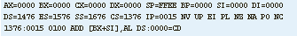

Select one:

1. EXE program

Determine the content of register BL after the following instruction have been executed:

a) E2H MOV BL, 2EH

MOV CL, 0100b

ROL BL, CL

OTHER

A “pull down” resistor is used in digital circuits to do what?

b) To keep the signal line “tied” low until the line is active (goes high)

A “pull up” resistor is used in digital circuits to do what?

c) To keep the signal “tied” high until the line is active (goes low)

Double precision IEEE FP standard uses _____ nibbles to represent data:

1. 16

How many bytes are in double precision IEEE floating point format numbers?

1. 8

You are trying to rebuild a Hello project program in MASM and you get the following error: “LINK : warning L4021: no stack segment”.

1. No project template for COM was selected

How many double words are in double IEEE floating point format numbers?

1. 16

In x86 architecture, BIU stands for which of the following?

1. Bus Interface Unit

Moore’s law has accurately predicted the growth rate in the number of transistors per die for the last 40 years. What is that rate?

b) Doubling every 18 – 24 months

NMI stands for what?

1. Non Maskable Interrupt – it means it cannot be blocked

The letters “NC” labeled on relays and PLCs means which of the following?

1. Normally Closed

The number of bits in single precision IEEE floating point format are:

1. 32

The number of bytes in extended precision IEEE floating point format are:

b) 10

The Ladder Logic diagram would represent which of the following?

1. XOR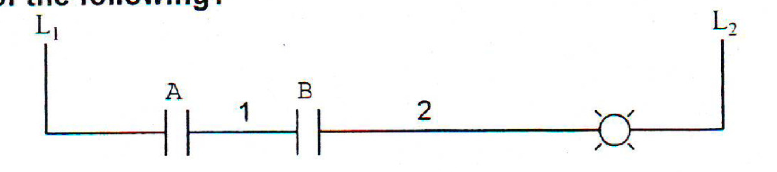
2. OR
3. NAND
4. AND
5. OPEN CIRCUIT

The Ladder Logic diagram would represent which of the following?

1. XOR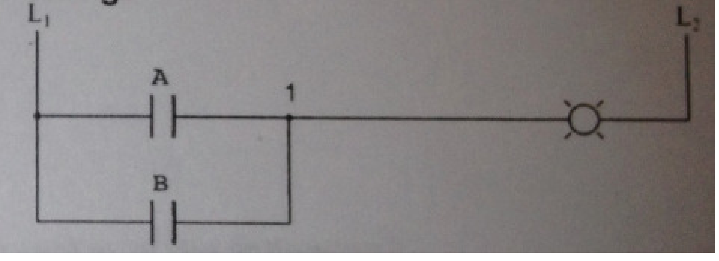
2. OR
3. NAND
4. AND
5. OPEN CIRCUIT

What is the decimal value of C1 1C 00 00 in IEEE single precision FP format?

1. -9.75

What is the advantage of Assembly Language over C Language?

a) The assembler creates much faster executable code

What is(are) the advantage(s) of C Language over Assembly Language?

1. C is transportable to other microprocessor architectures

What is the decimal value of C5 5A 57 00 in IEEE single precision FP format?

1. -3493.4375

PPE

On the PPE board, what number(s) on the key pad is(are) processed for an output port value of 08h and an input port value of 2Fh?

1. 0

On the PPE board, what number(s) on the key pad is(are) pressed for an output port value of 01h and an input port value of 1Fh?

1. 3

On the PPE board, what number(s) on the key pad is(are) pressed for an output port value of 02h and an input port value of 2fh?

1. 5

On the PPE board, what number(s) on the key pad is(are) pressed for an output port of 04h and an input port value of 2Fh?

1. 8

What Hex values must be sent to address the key pad rows on the PPE boad?

1. 1,2,4,8

What is the numeric sequence of the key pad columns on the PPE board?

1. 37, 2F, 1F

What is the numeric sequence to address the key pad rows on the PPE board used in the lab?

1. 1,2,4,8

Arduino

Which of the following instruction would be used to set the LED to light on the Arduino Platform?

1. LED = 1

On the Arduino platform, what is the programming language used?

1. C

Microchip PICKIT

How many bits does the PIC 18 microcontroller used in the PICit 3 Debug Express have?

1. 16

In the PIC18 with TRISD = 0b10000000, what is the configuration of the Port D?

1. Bit 7 of port D is set to input

In the PIC18 with TRISD = 0b00001111 and LATD = 0xAA, what value will be on Port D and shown on the LEDs?

1. A0

In the PIC18 with TRISD = 0b11110000 and LATD = 0xAA, what value will be on Port D and shown on the LEDs?

1. 0A

In the PIC18 with TRISD = 0b01111111, what is the configuration of the Port D?

1. Bit 7 of port D is set to output

Which of the following would be used to set the TRISA register to control the direction of the PIC18 Port to input?

1. 1

A “POPstruction:

Increments the SP

With a “POPAX” instruction, what will the order of the accumulator, base, count, and data registers restored from the stack?

ax

DAS used for BCD operation stand for which of the following?

Decimal adjust for subtraction

What is -1011.0101 in decimal?

-11.31

what is -32.75 in binary?

100000.11000

what command in debug would be used to change the IP value?

RIP

What is -130 decimal in 2’s complement (8 bits)?

01111110

what is the decimal value of C5 5A 57 00 in IEEE single precision FP format?

-3493.4375

**In the Propeller, how many values does a method return?**

d. **1**

**Which of the following DOS Debug instructions would be used to change the AX register to 010C?**

d. **RAX = 010C**

**24 decimal would be what value in hexadecimal?**

b. 18

**AND’ing 10Hex and 2FHex will result in which of the following Hex numbers?**

e. **0**

**What high level language(s) is(are) the propeller programmed in?**

d. **C and Spin**

**How much global RAM does the Propeller microcontroller have?**

c. **32KB**

**Hex F2 in base 2 equalsPOP AX0b10000000**

b. 1111 0010

**A microprocessor with a 26-bit address bus could access how much memory?**

e. **64 MB**

**12 hexadecimal would be what value in decimal?**

a. 18

**In the PIC18 with TRISD = 0b11111111, what is the configuration of the Port D?**

b. **Port D is set as an input port**

**If CX is 0000 what will CX be after a “LOOP” x86 instruction?**

c. **FFFF**

**In the PIC18 with TRISD = 0b01000000, what is the configuration of the Port D?**

b. **Bit 7 of port D is set to output**

**What command in DEBUG would be used to execute interrupts without stepping through the interrupt instructions?**

c. **P**

**What is the hexadecimal encoding for adding BX with CX and storing the result in BX?**

a. **01CB or 03D9**

The letters “NO” labeled on relays and PLCs means which of the following?

Select one:

c. Normally Open

How many nibbles are in extended precision IEEE floating point format numbers (80bit)?

20

In the PIC18 with TRISD = 0b11111111, what is the configuration of the Port D?

Port D is set as an input port

POP AX

How many nibbles are in single precision IEEE floating point format numbers (32bit)?

8

Given the short sequence of instructions (code), what is the value in BX after the program is run?

Program Listing

Mov BX, 0100

Push BX

Mov AX, 0500

POP AX

b. 0100

For the instruction sequence below, determine the contents of the register AL after this program is executed:

Program Listing

MOV AL, 83h

ADD AL, 68h

DAA

c. 51h

Which of the following will cause a program with a LOOP instruction to loop 48 times (decimal)?

g. CX = 30h

How many bytes are in single precision IEEE floating point format numbers (32bit)?

4

Given the short sequence of instructions (code), what is the value in BX after the program is run?

Program Listing

Mov BX, 0001

Push BX

Mov AX, 0500

POP AX

c. 0001

What command would you use to light up an LED on port 5 on the Arduino platform?

d. pinMode(5, OUTPUT)

With a PUSHA instruction, what will be the order of the accumulator, base, count, and data registers stored on the stack?

c. ACDB

On the Raspberry Pi platform, what is the processor used on the board?

g. ARM

The instruction MOV CX, [4DAD] is what addressing mode?

b. Direct